POWER BI WORKSHOP

DAY-1

**Latest Technologies:**

AWS

S3

Bucket

**Terminologies:**

Dataset

Databricks

Lakehouse

Warehouse

** pystore: PyStore is a simple (yet powerful) datastore for Pandas data frames, and while it can store any Pandas object, it was designed with storing time series data in mind.

Data Source: Kaggle

Dataset name: Global Superstore sales data of Walmart

**Types of views in Power BI:**

1. Report view

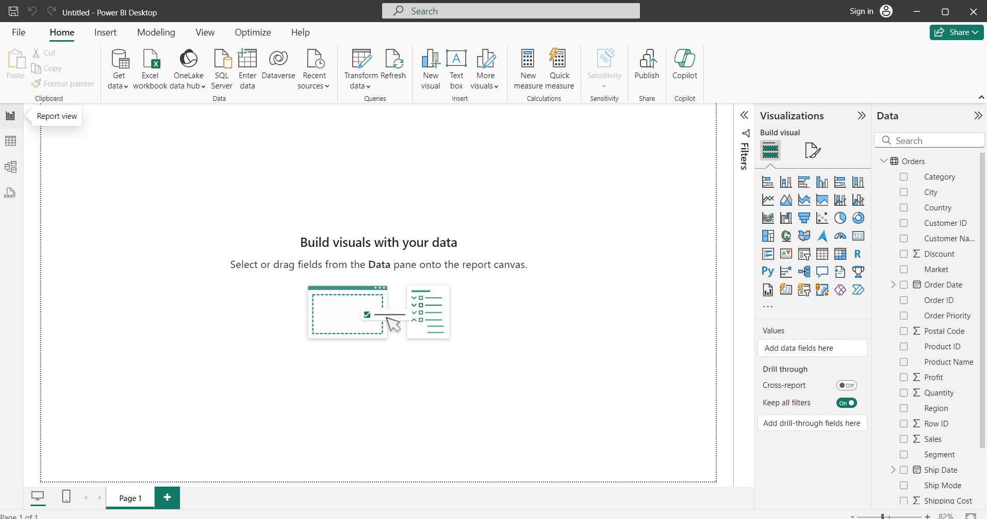

1. Table view

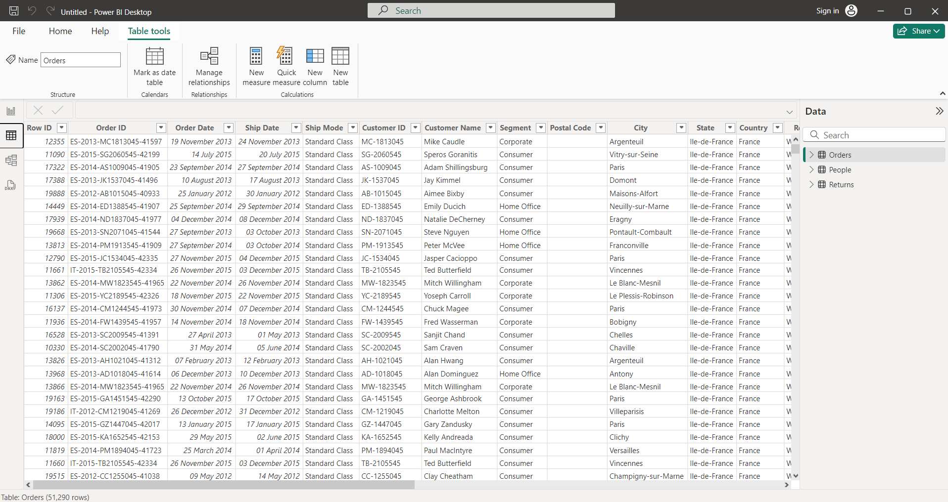

1. MODEL VIEW: to understand the relationship between different tables.

Power BI has AI-enabled features

**Structured data:**

1. Quantitative (measurable)
2. Qualitative (unmeasurable)

**Load the data:**

Get Data ->Excel workbook -> Downloads -> select data

Select all 3 datasets and click on Tansfom data

Click on Close&Apply

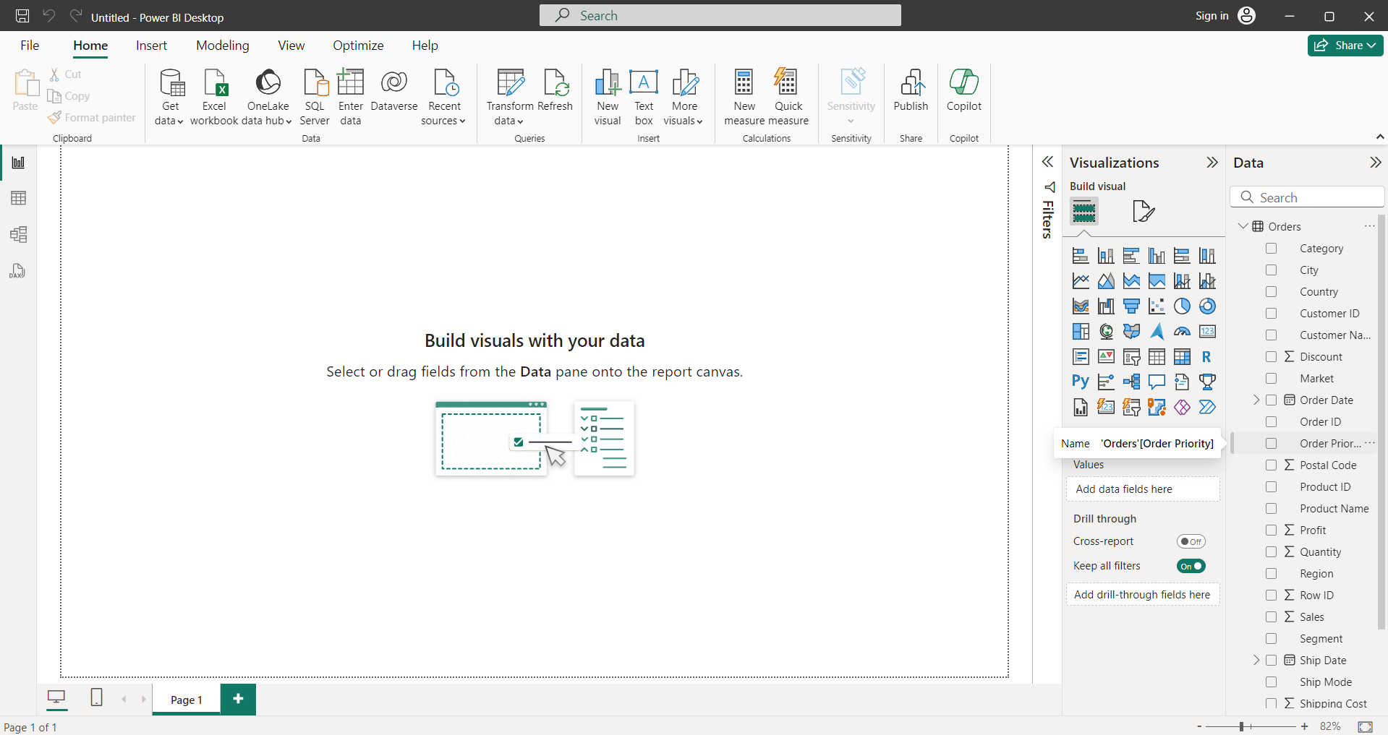

Click on model view

In the orders table select and drag order ID to the returns table to establish the relationship between them and click on Save.

In the orders table select and drag the order ID to the people table to establish the relationship between them and click on Save.(or) click on more options -> Manage Relationships

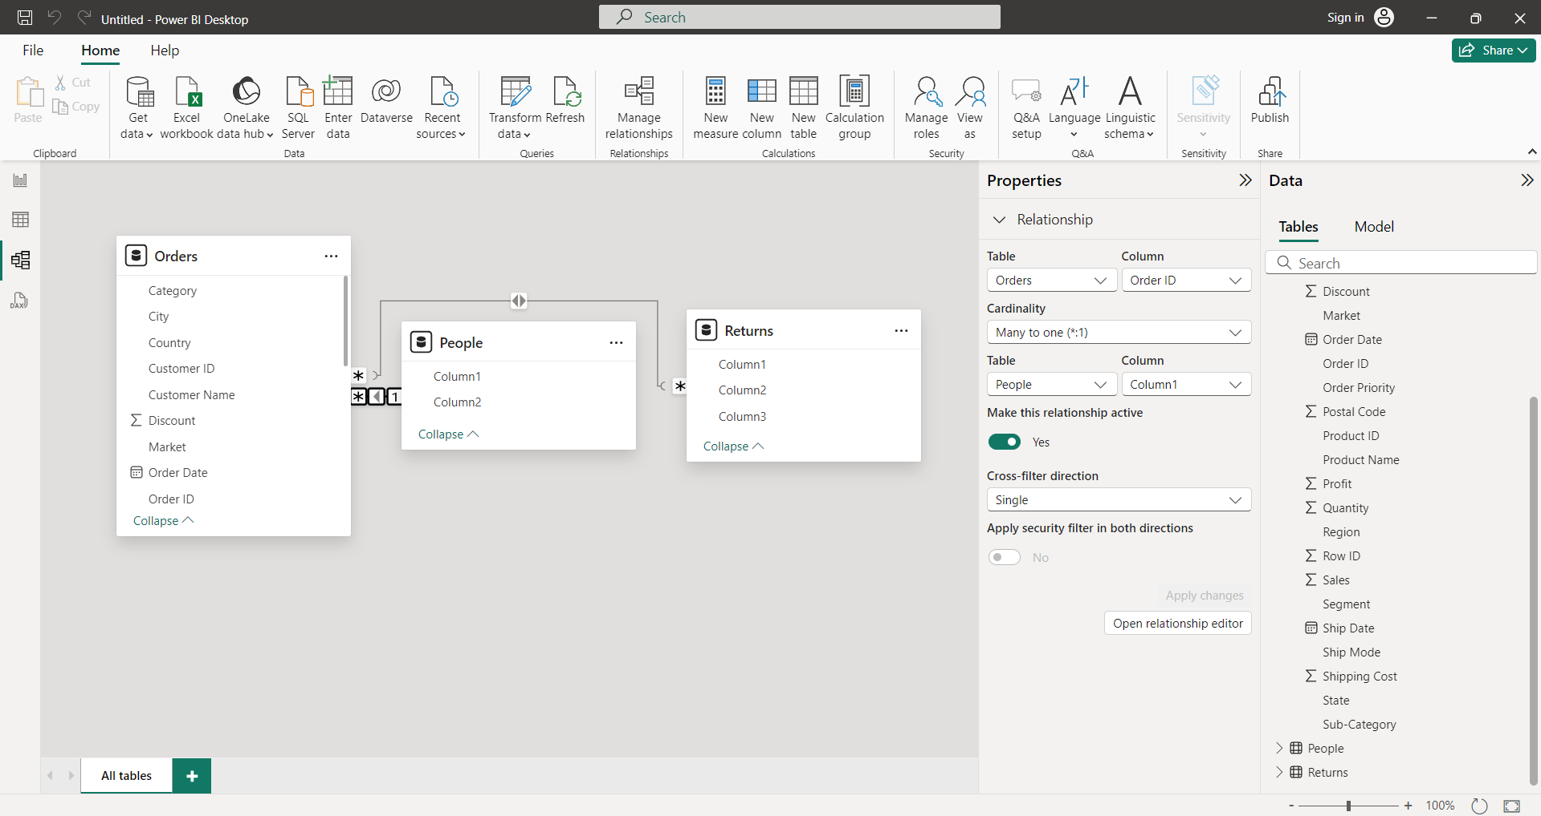

Click on Report View to build visuals from the data

**Bar chart:** to compare more than one column data

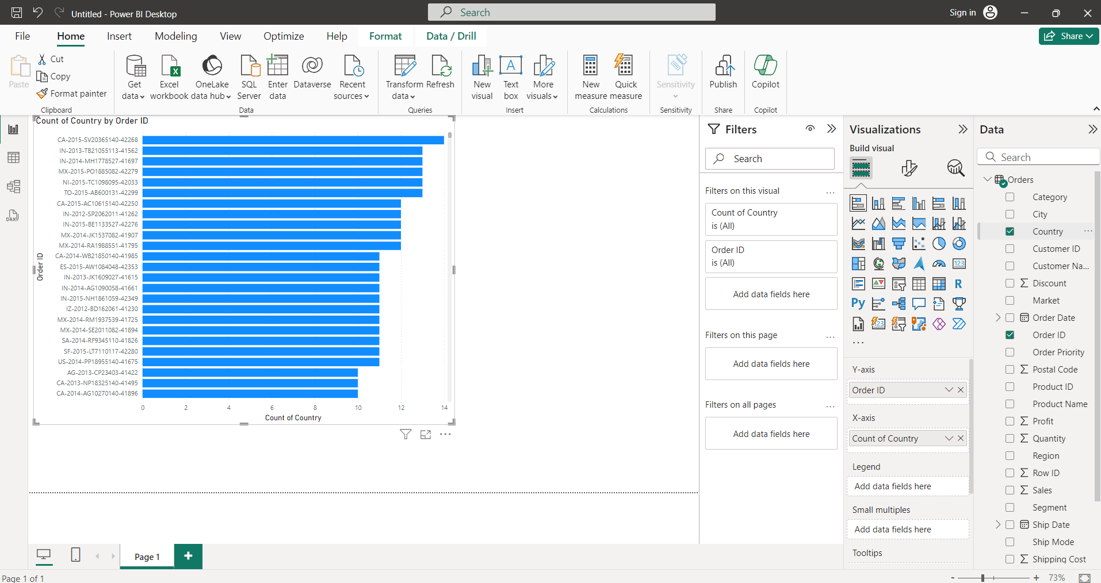

**Line chart or Trend chart**: to represent trends like to compare profits

X axis: time

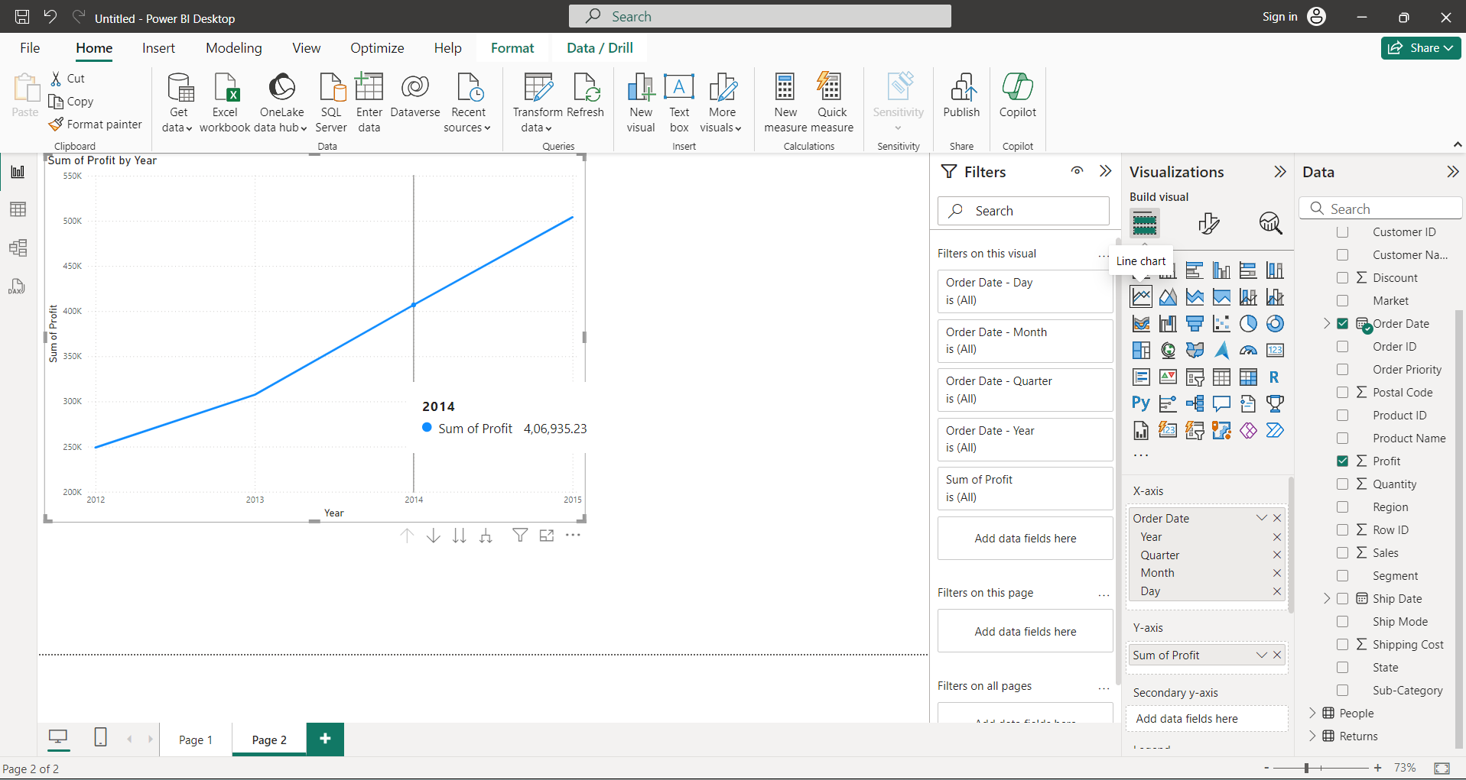

To get average click on v beside profit and select average

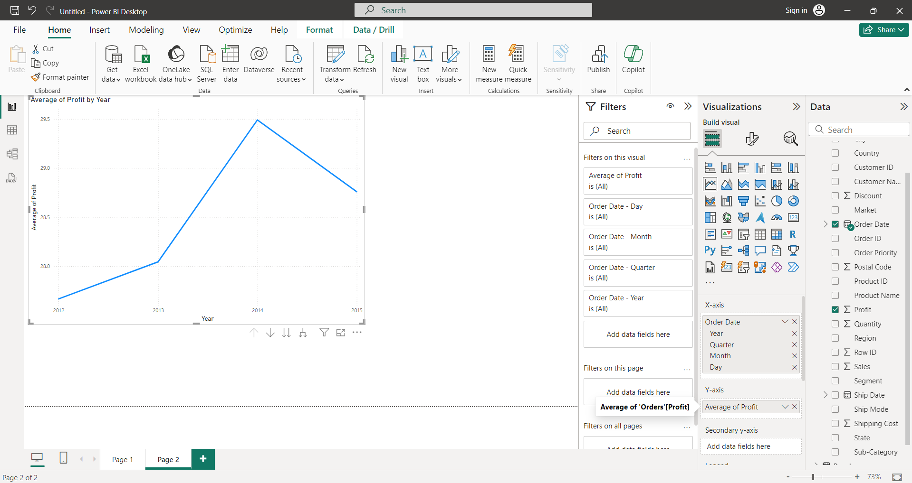

Select secondary Y-axis: count of orderID

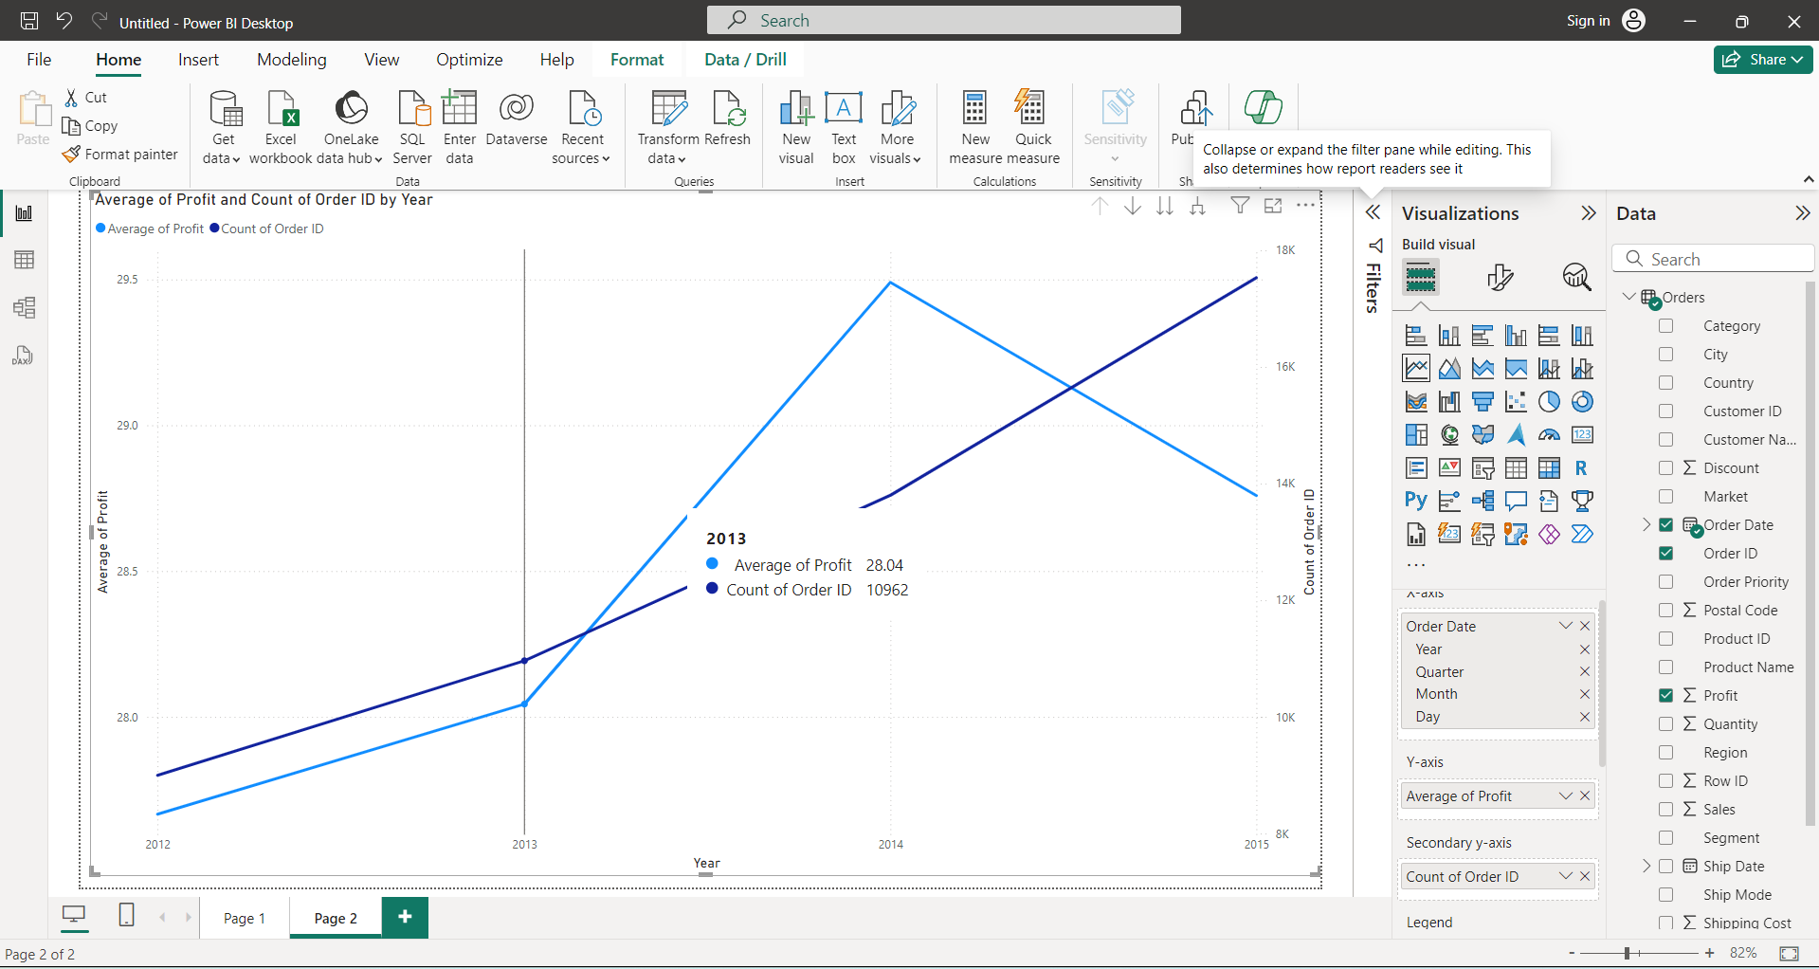

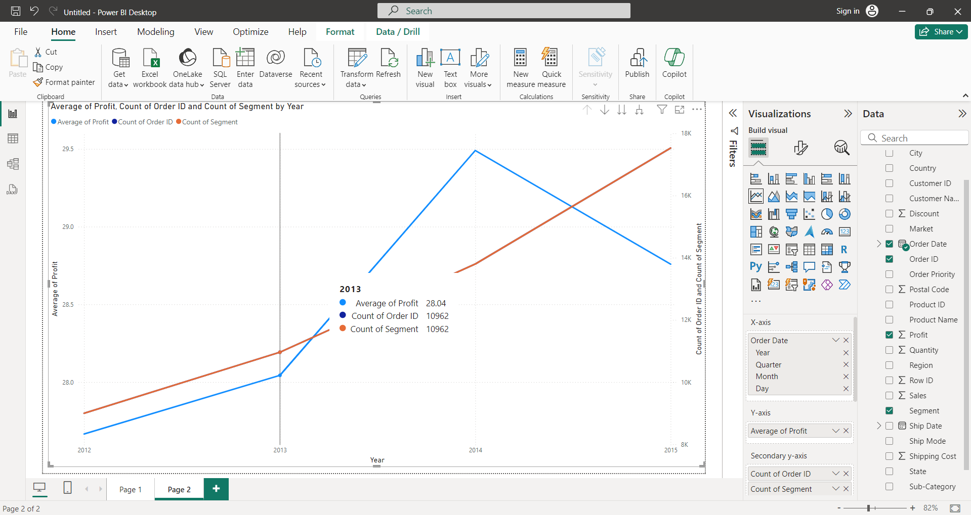

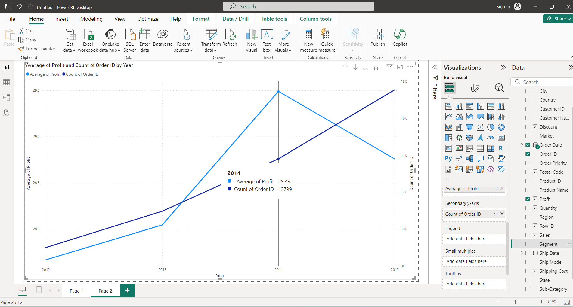Click on above chart and select segment

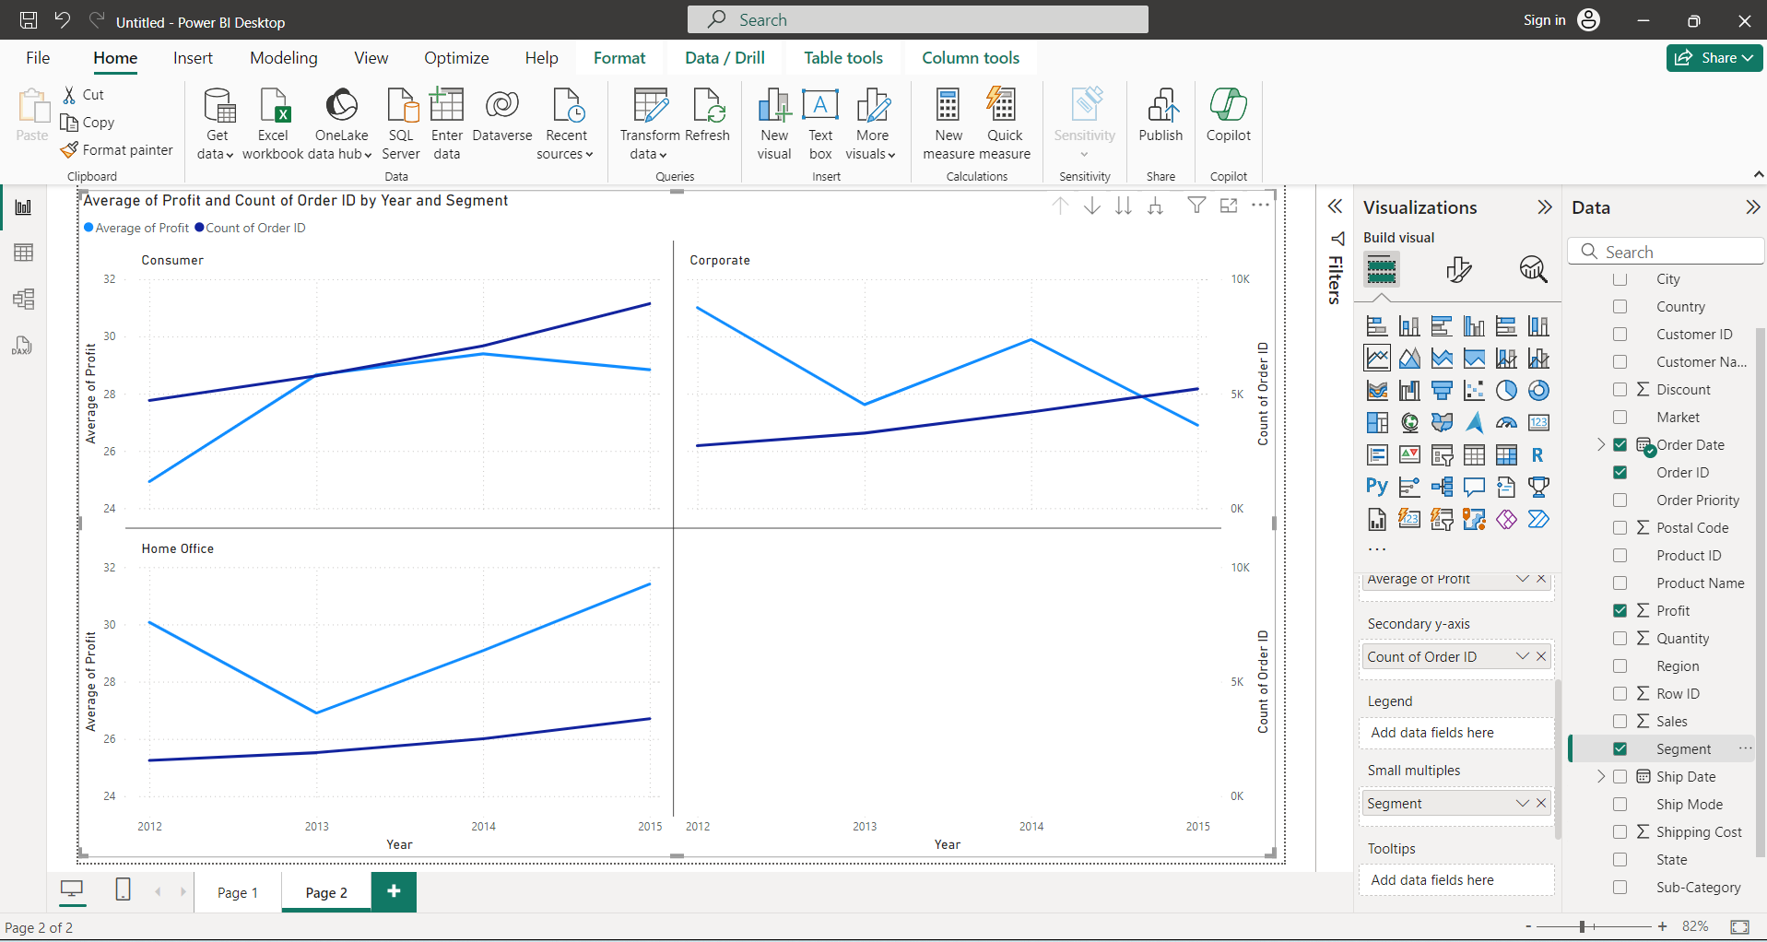

Legend, Small multiples, Tooltips: Accepts only Qualitative data.

Formatting Visuals:

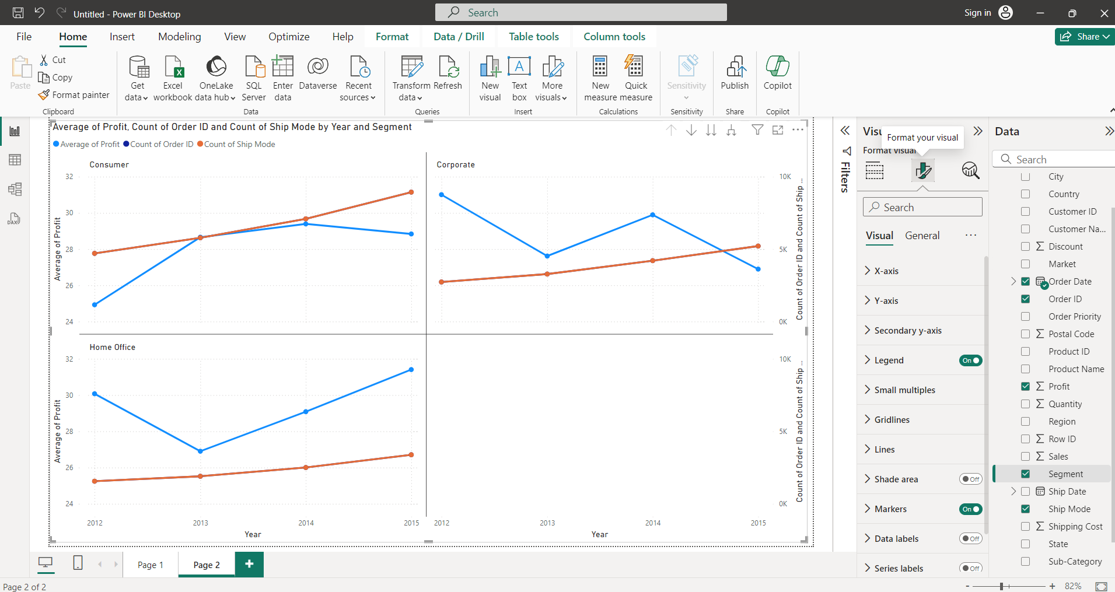

**Increasing font in X-axis labels:**

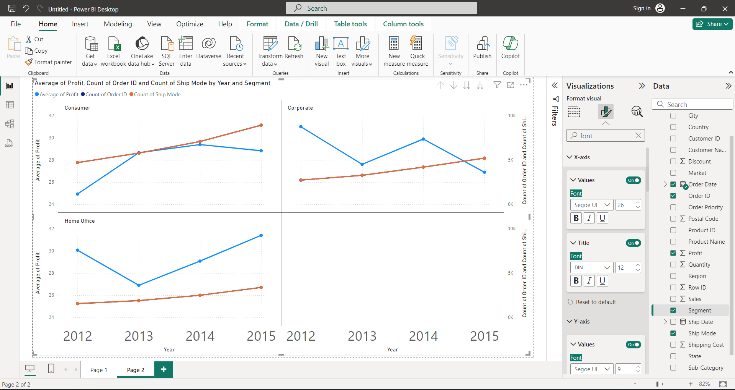

**To change color of X-axis labels:**

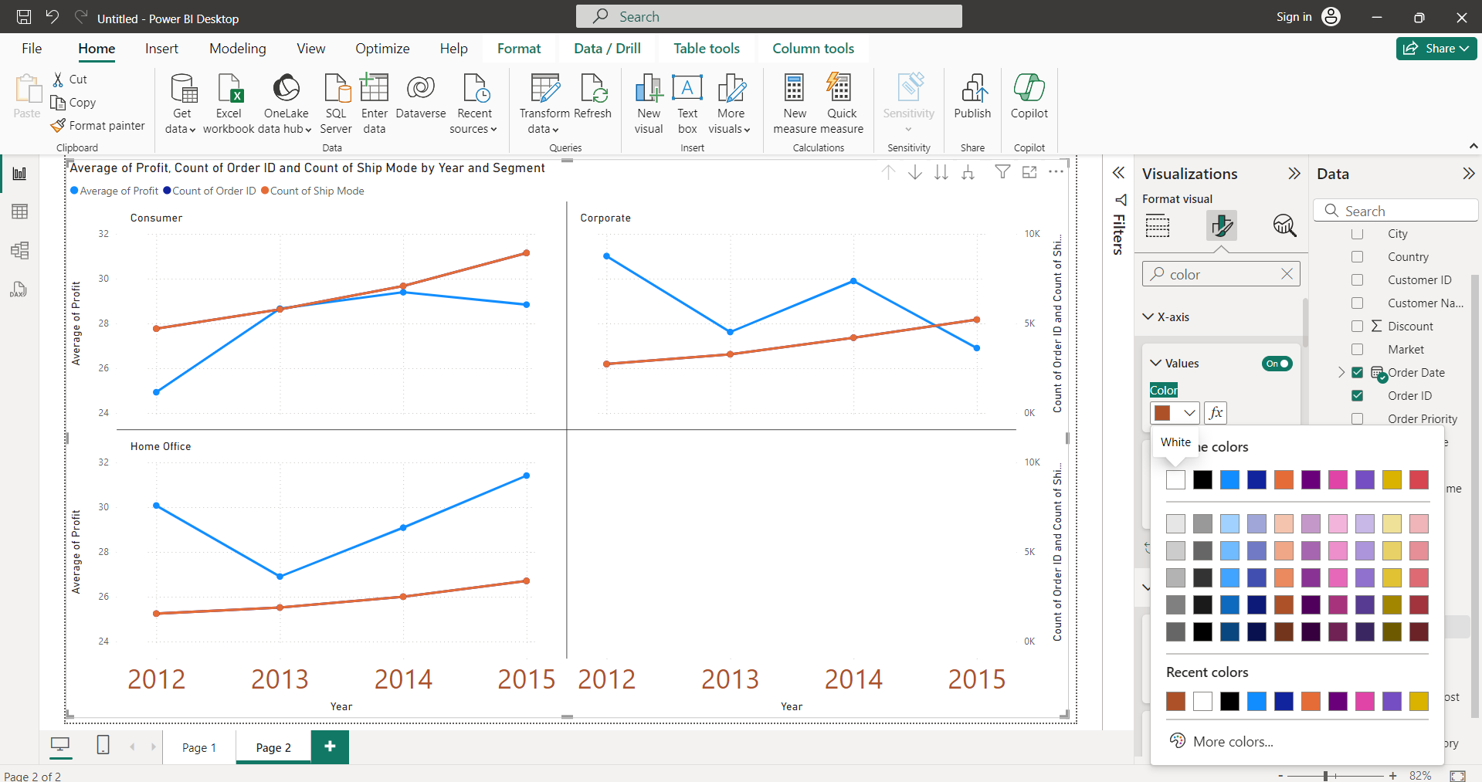

**Legend:** changed to bottom-right

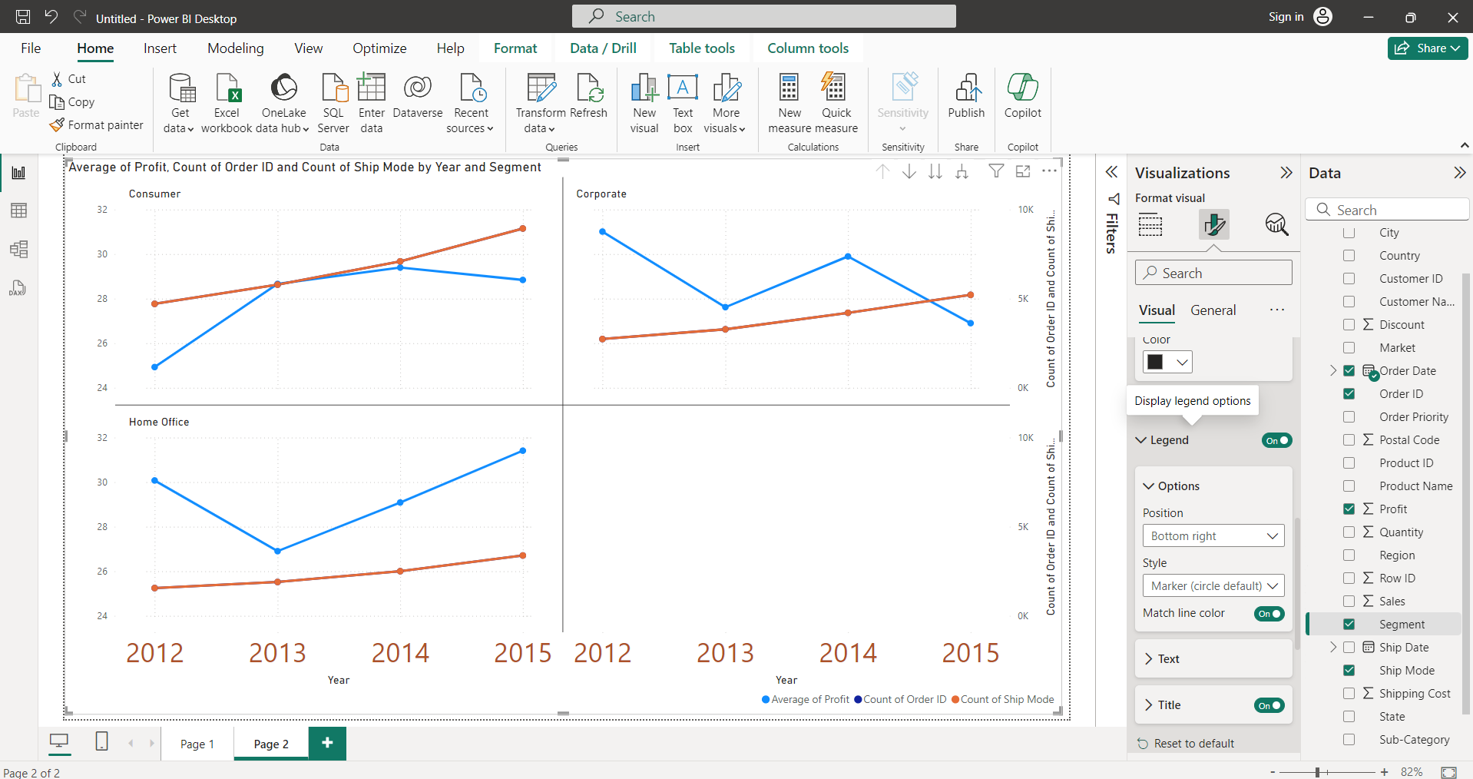

To increase number of grids:legend->

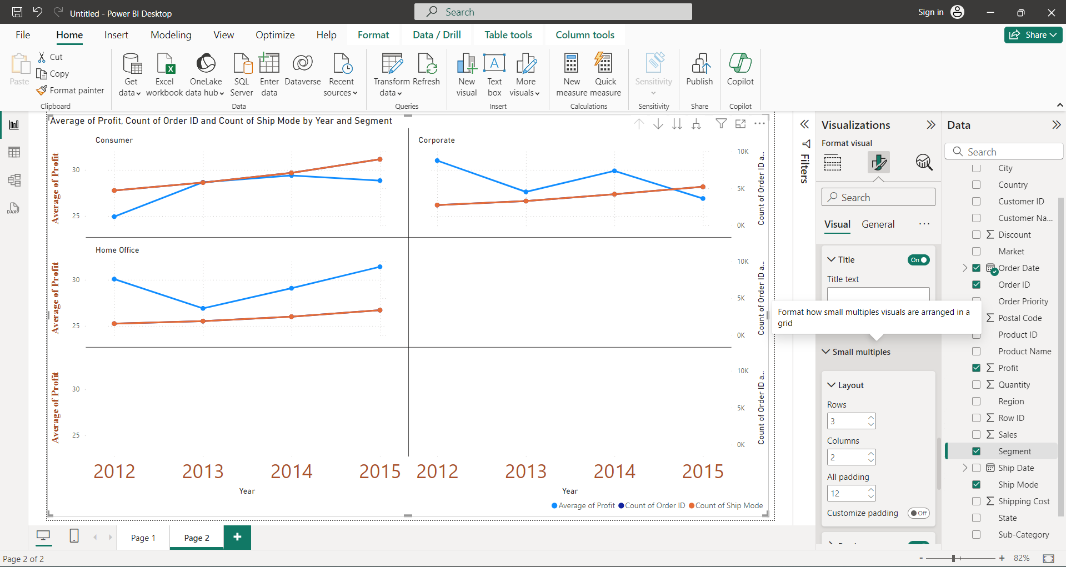

To change line style to dotted lines:

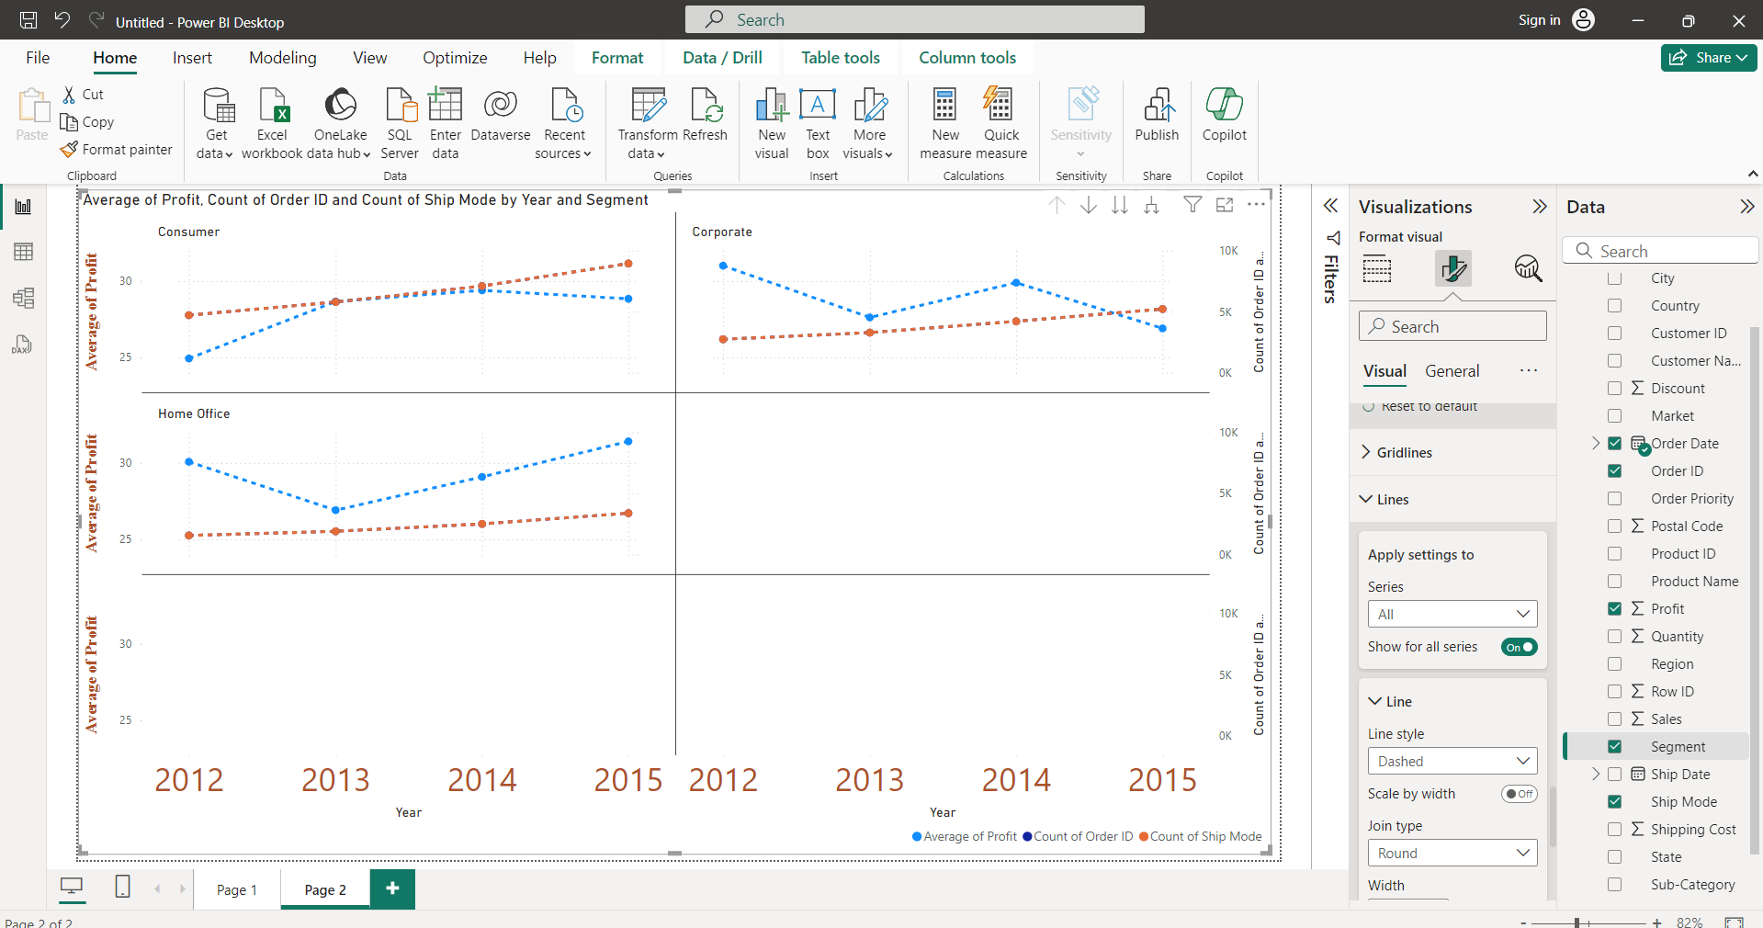

Markers:

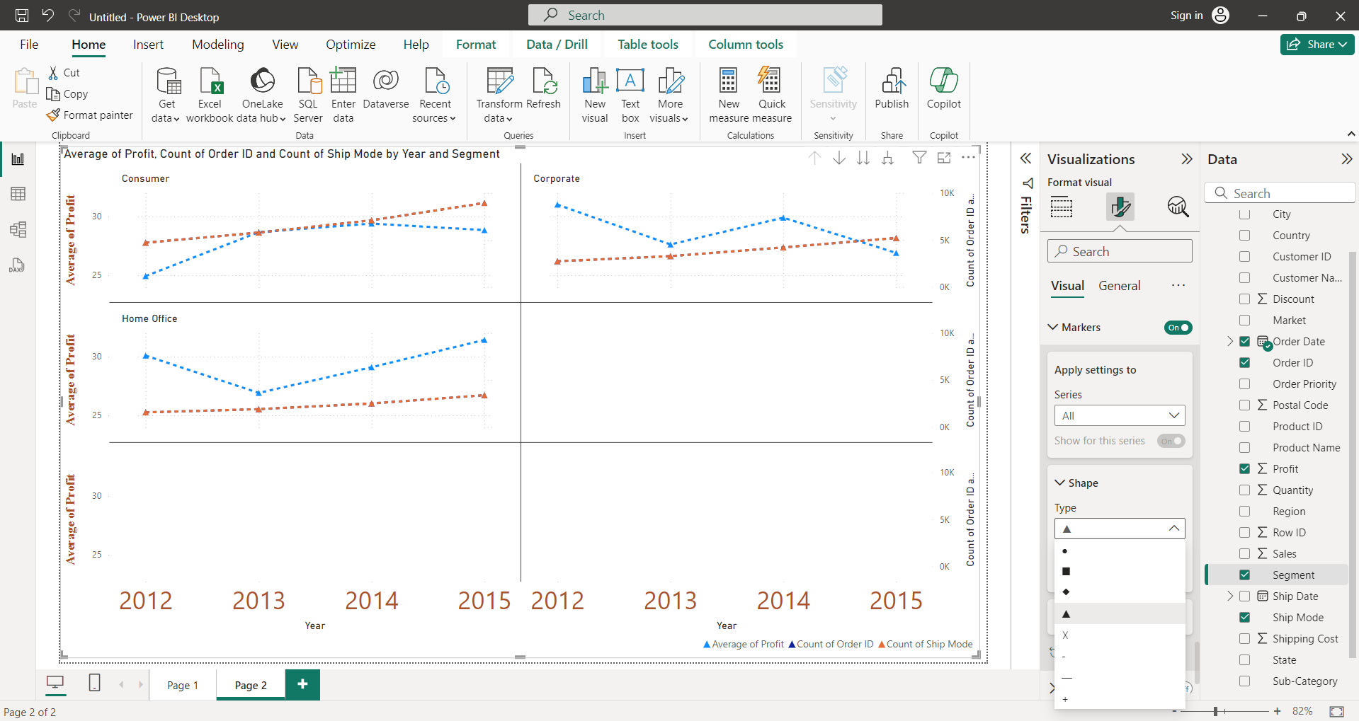

Data labels:

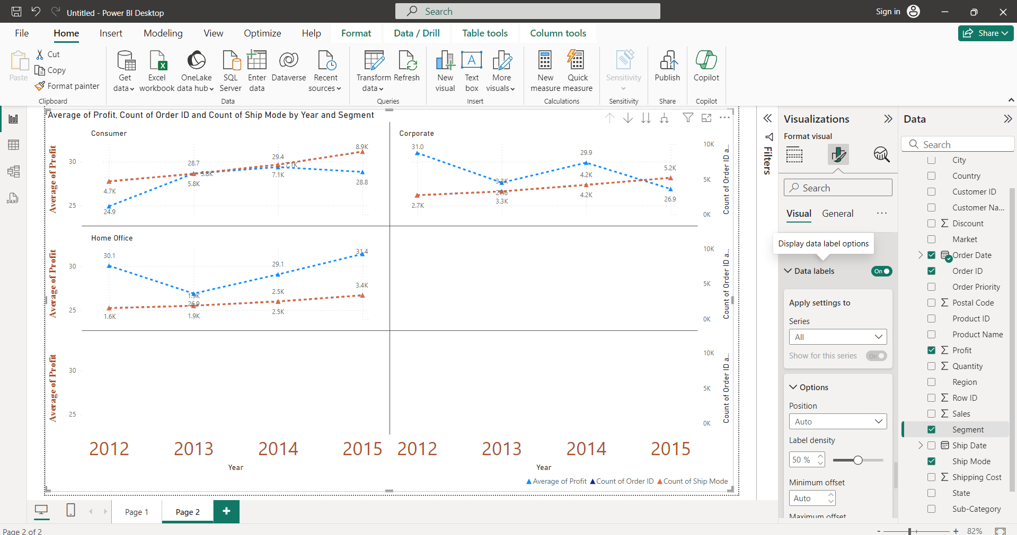

Background:

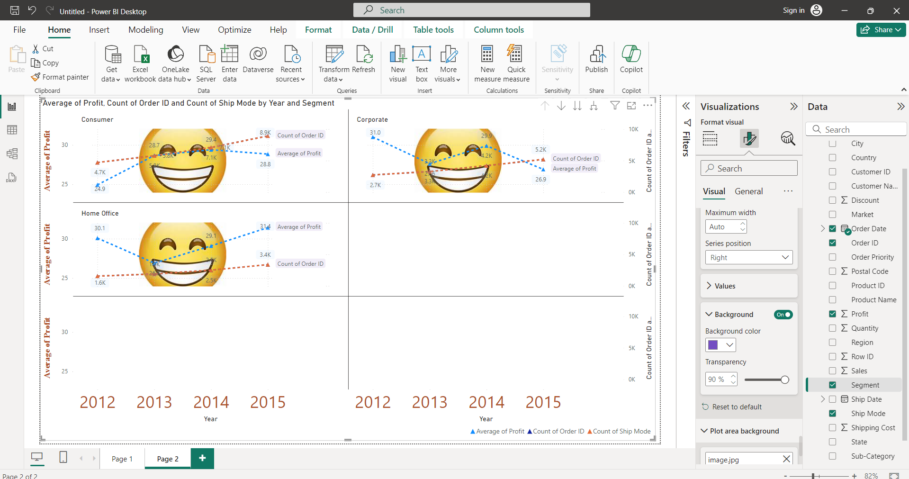

Plot Area Background: to insert background image to plot

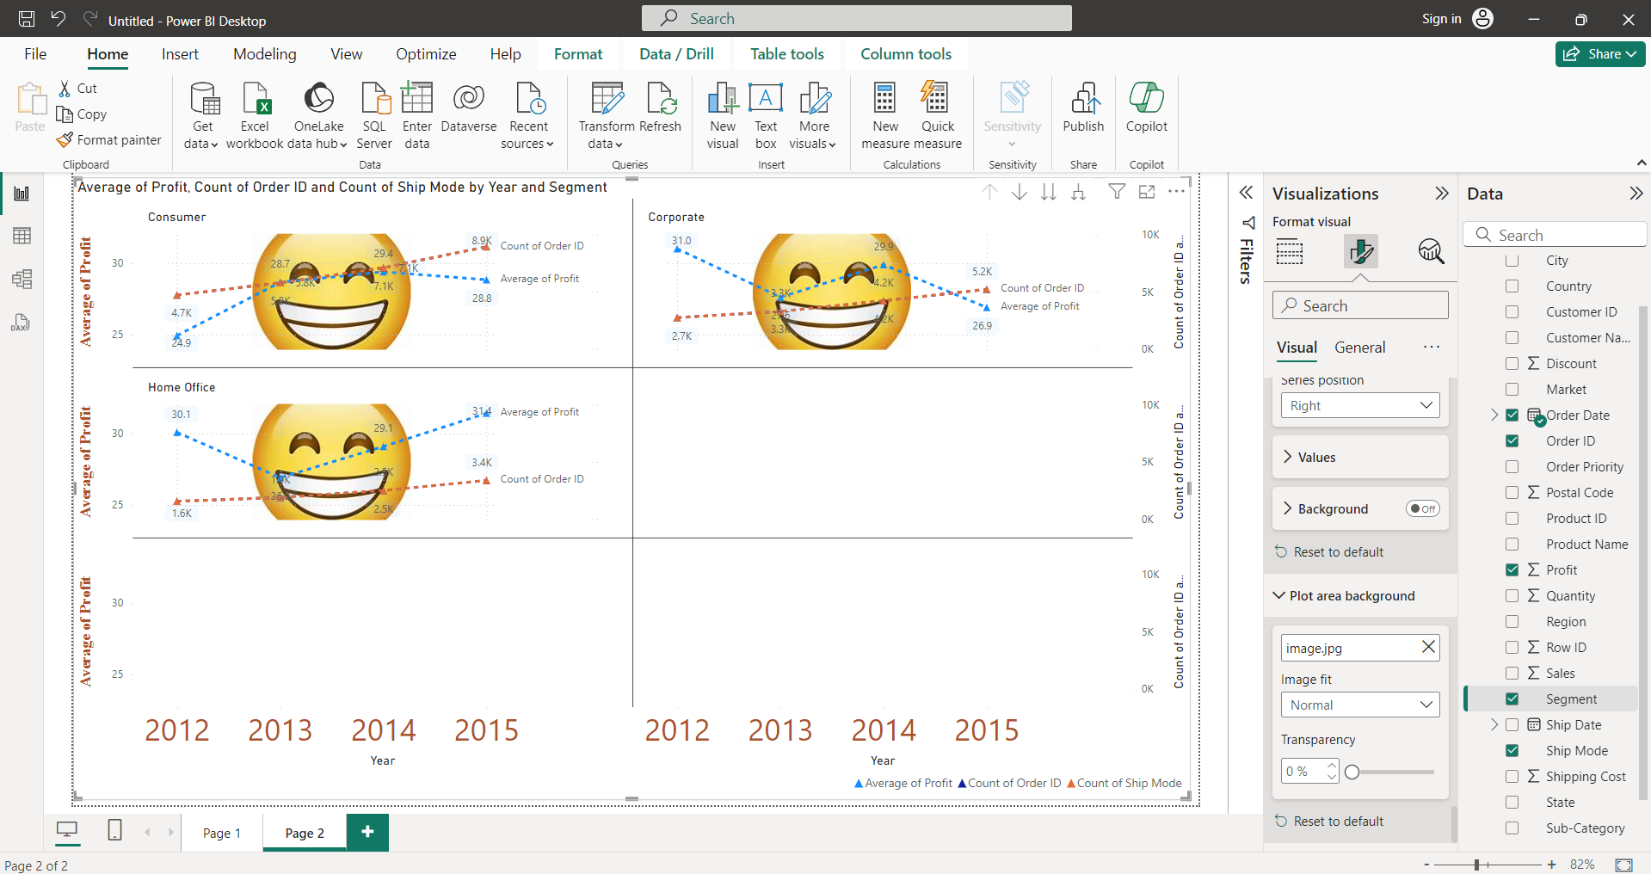

Format visual -> General

To change size of Heading:

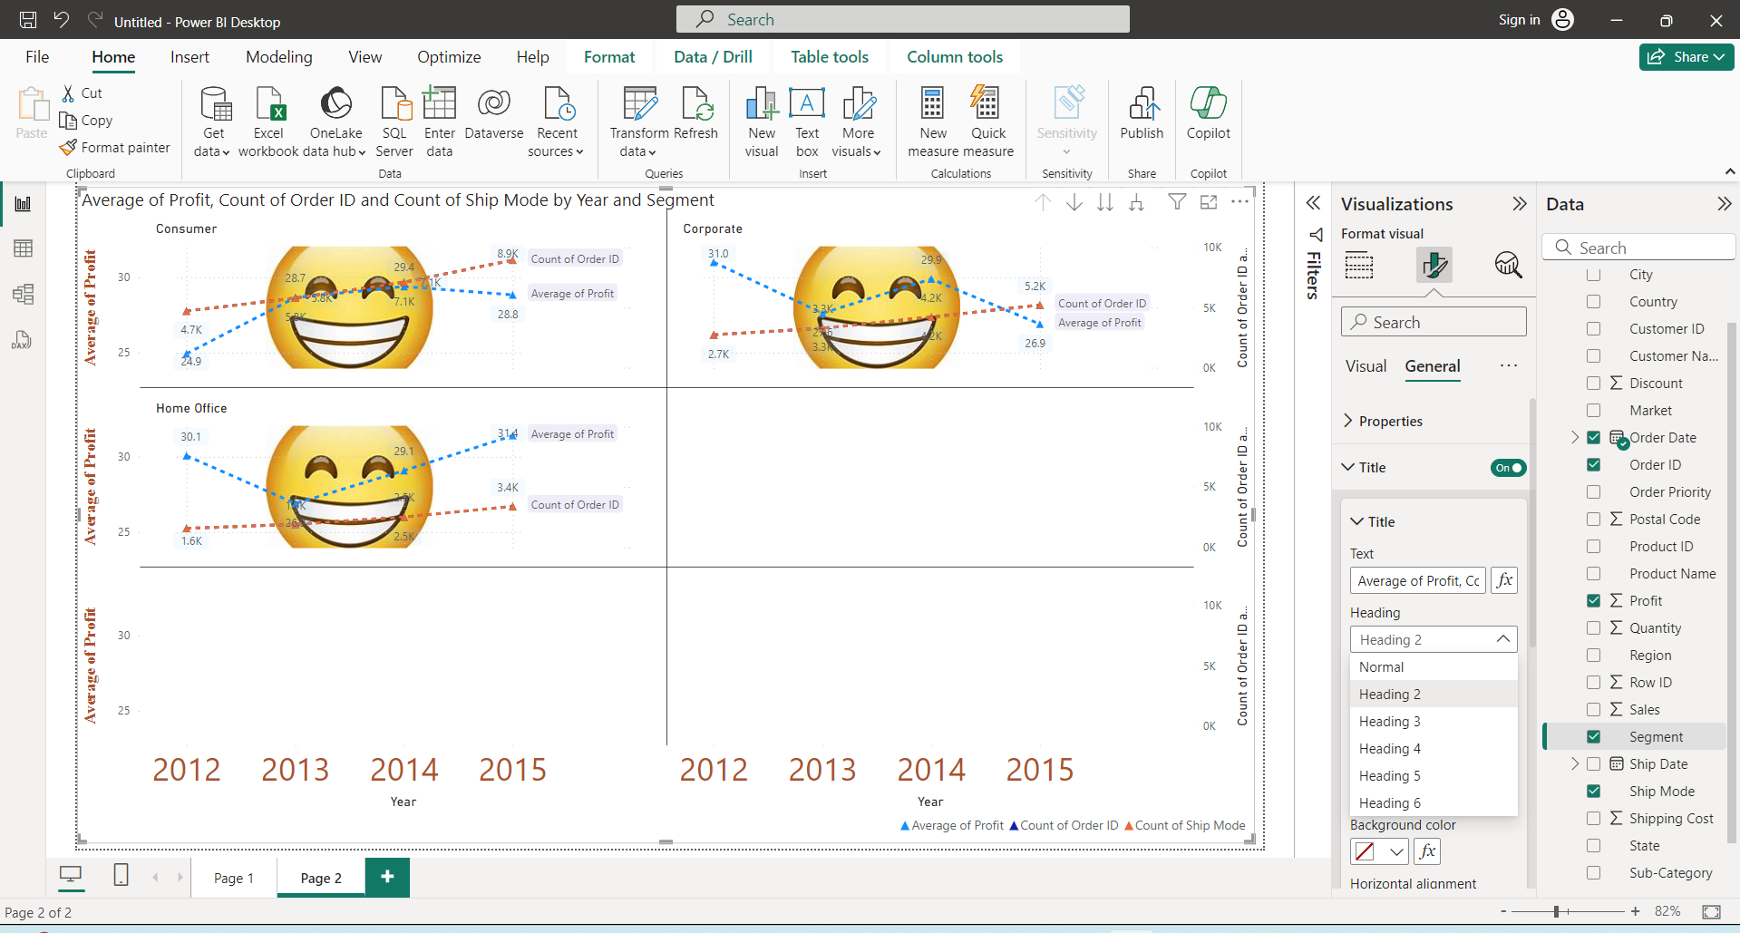

Bar chart should have 1 quantitative and 1 qualitative fields

Stacked Bar Chart:

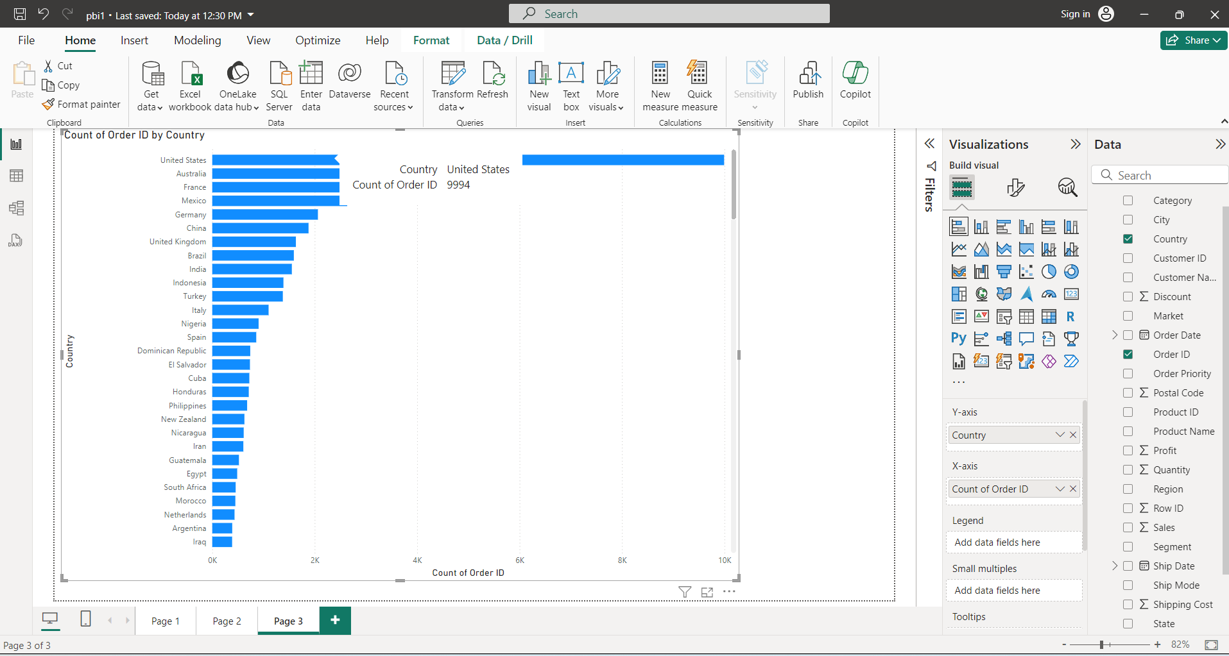

To display data in table:

Right click on visual -> show as table

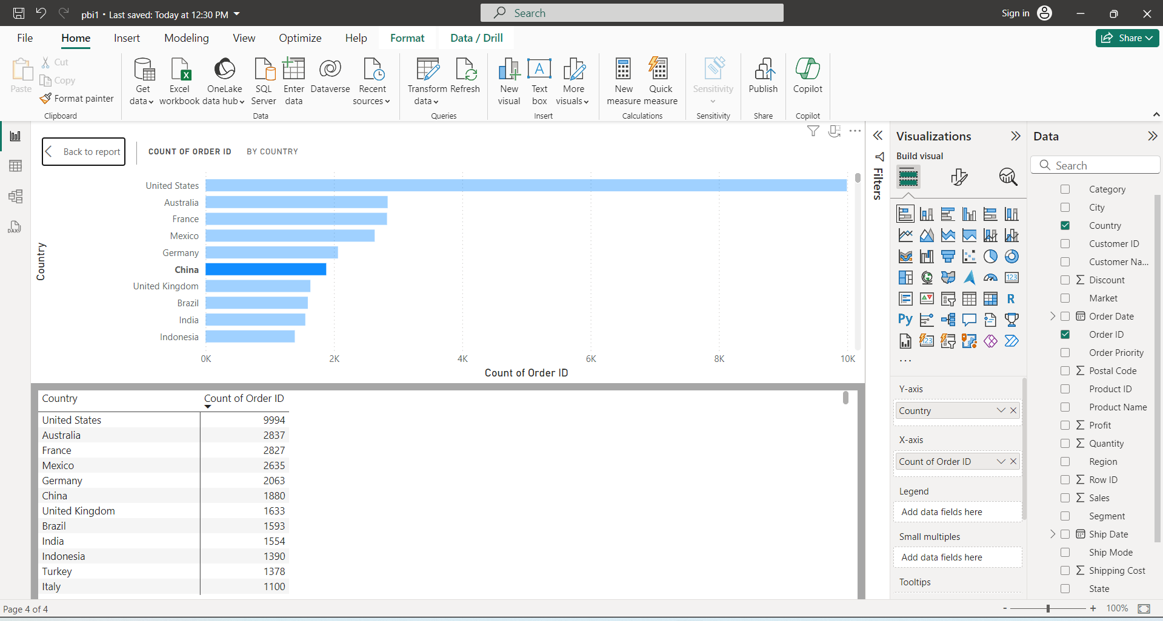

Multi Dimensional view helps to understand the data better.

To get multiple dimensions select and drag segments to small multiples.

A **stacked column chart** makes it easy for comparison.

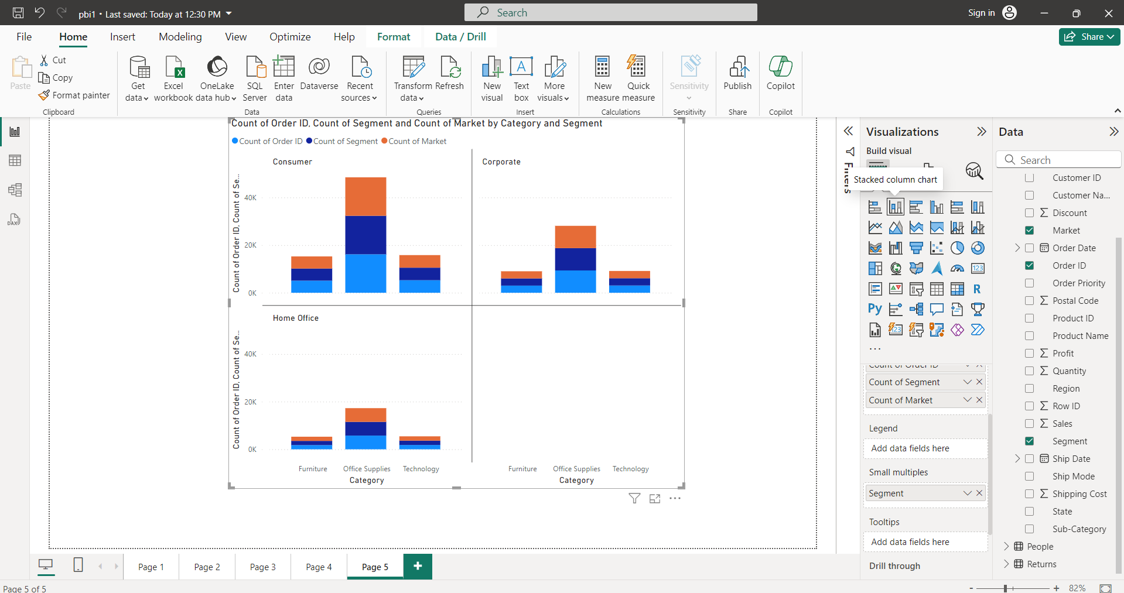

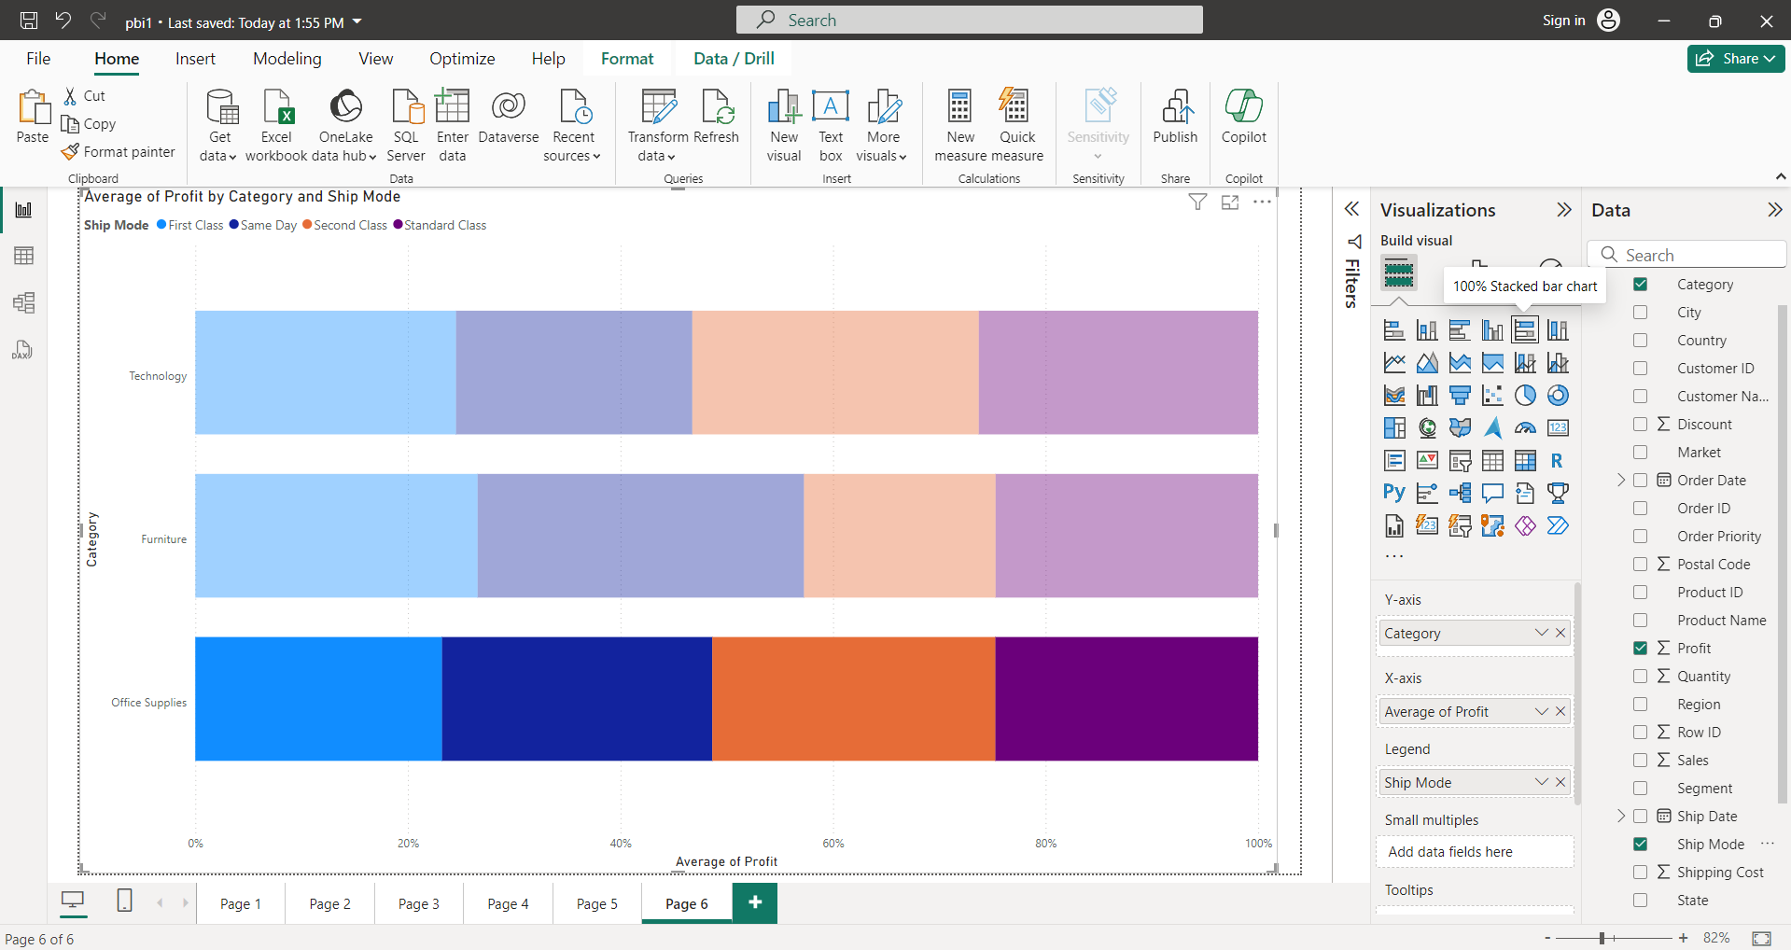

Stacked column chart:

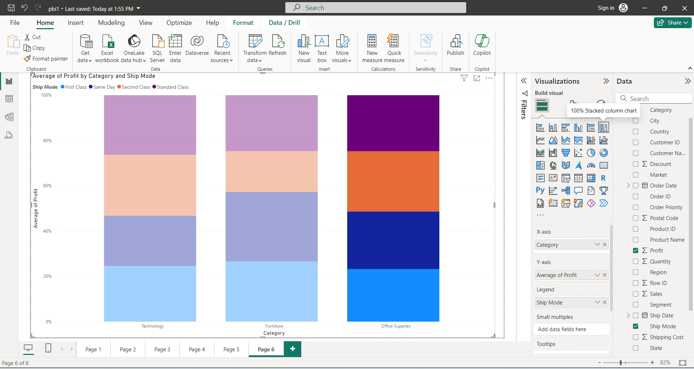

Line Chart:

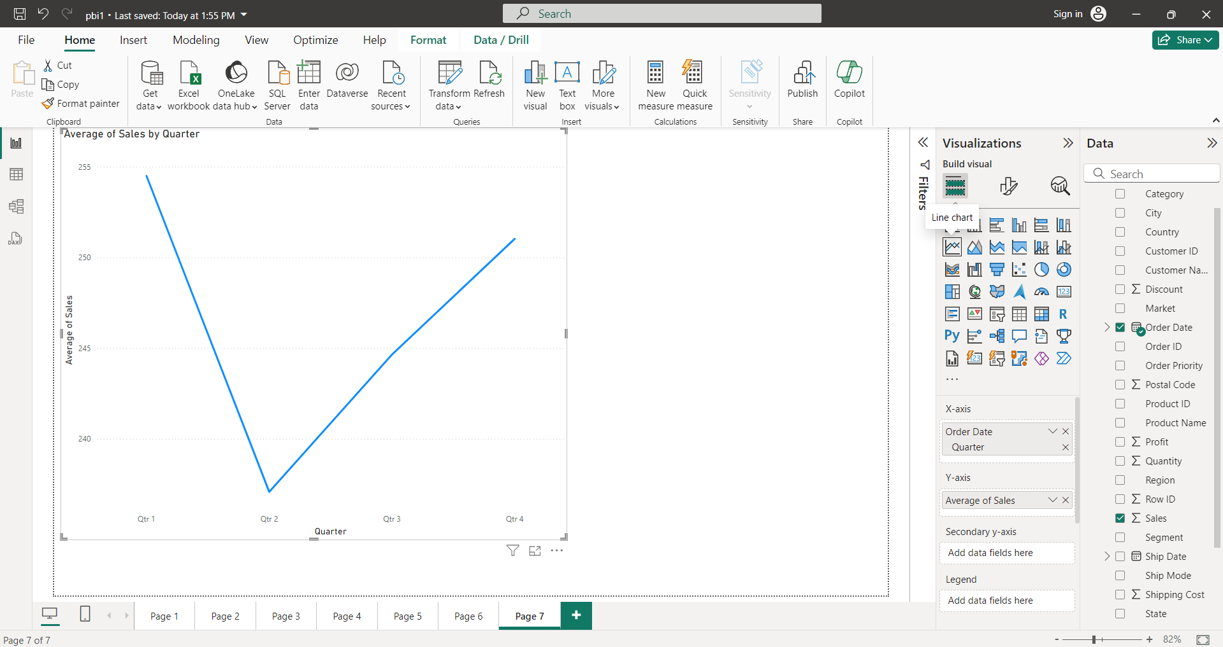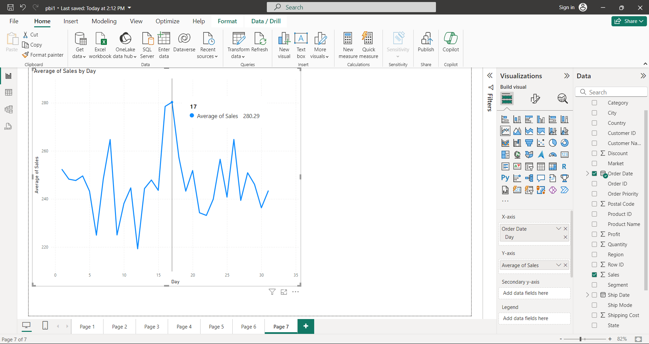

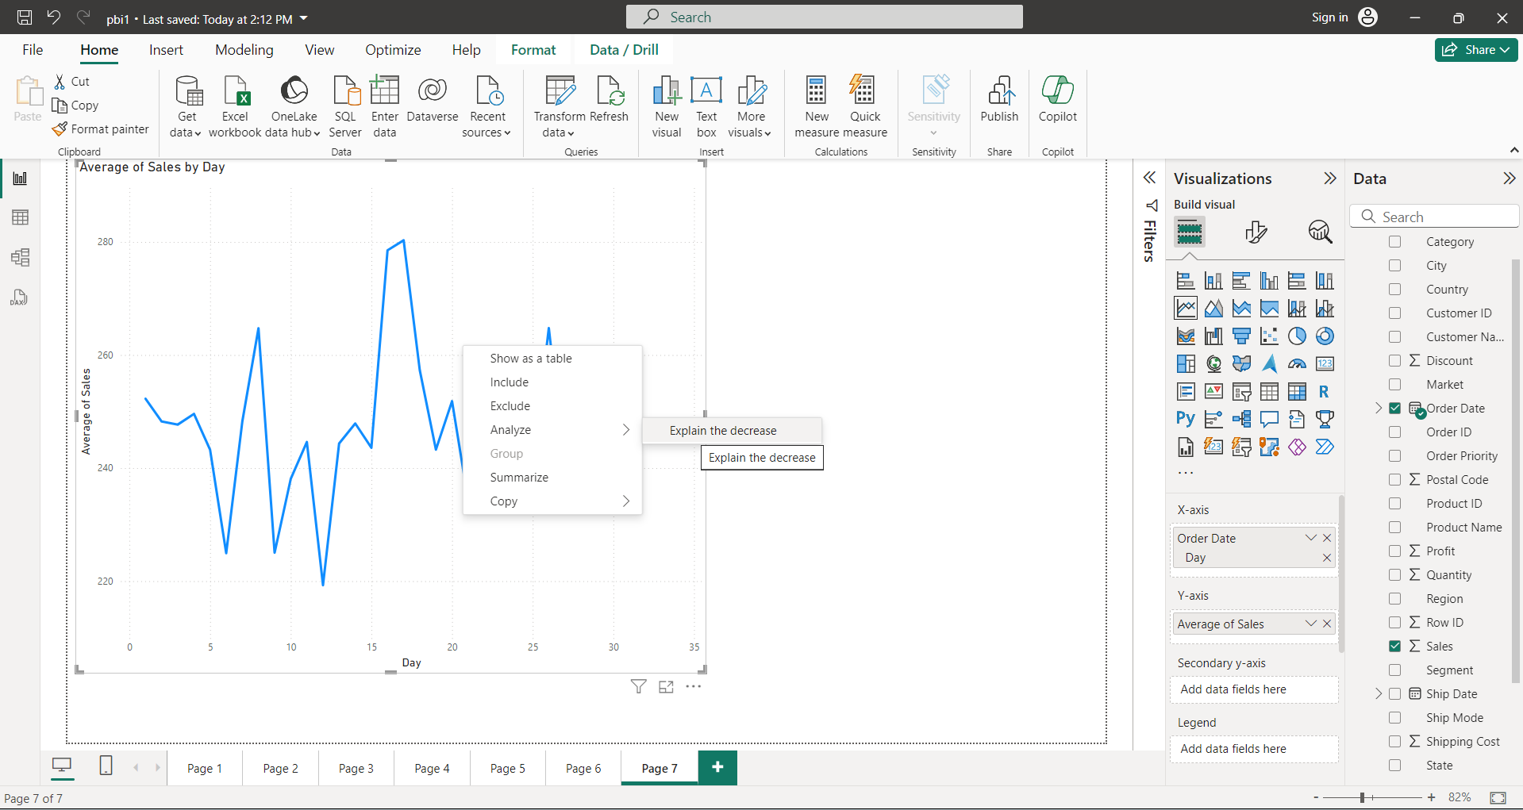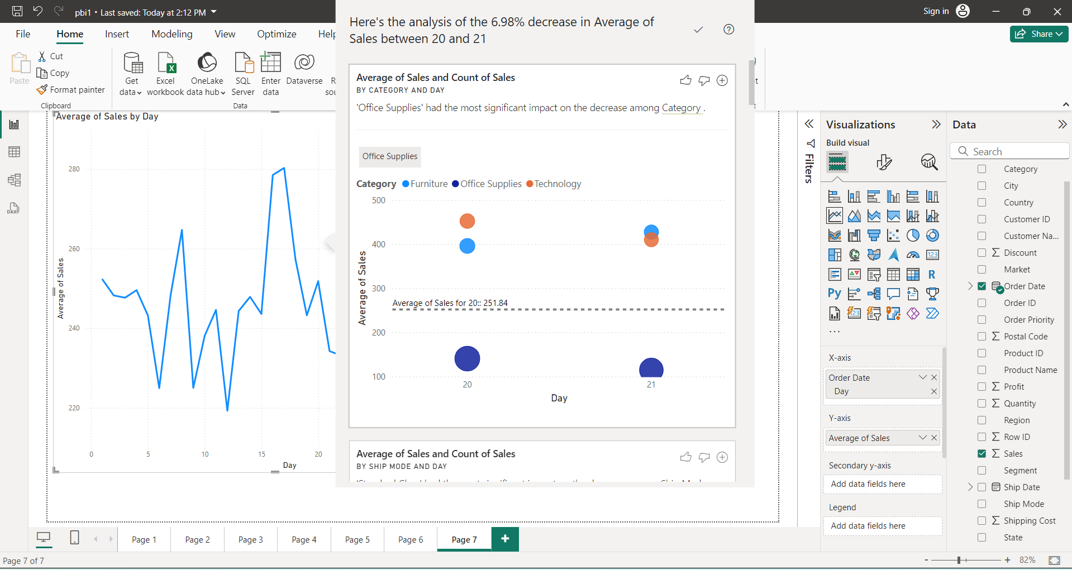

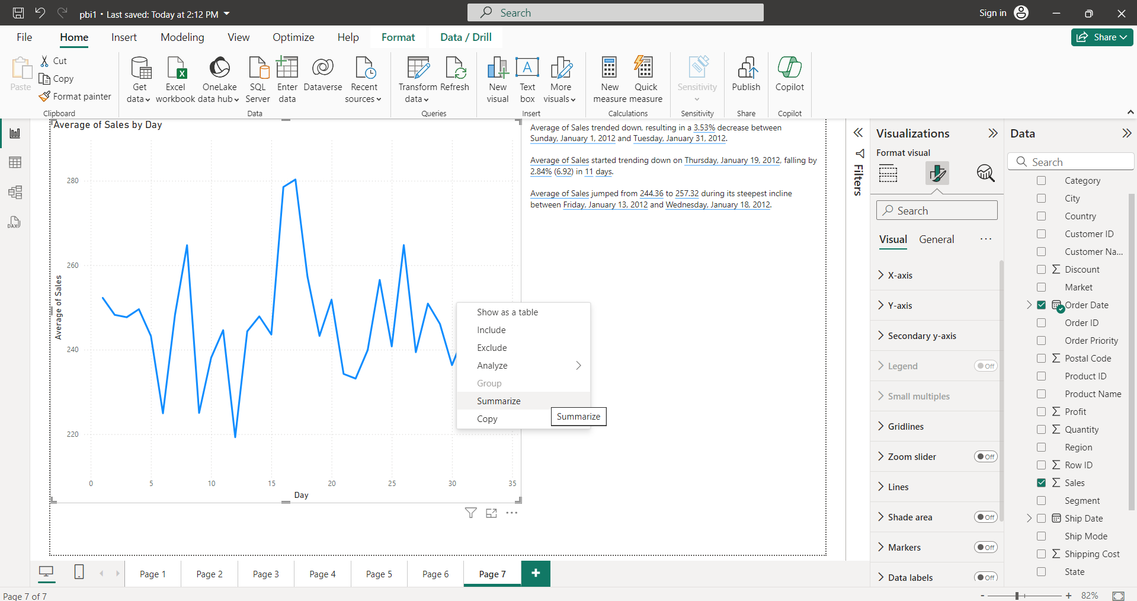

AREA CHART:

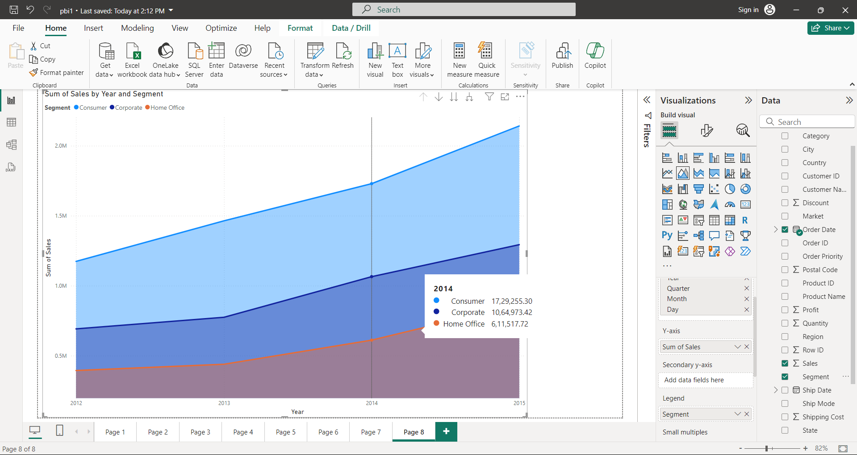

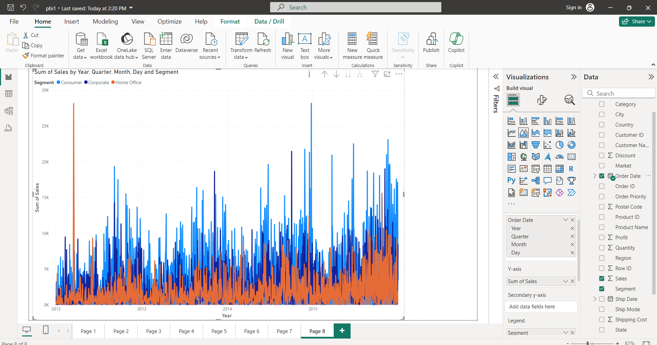

STACKED AREA CHART:

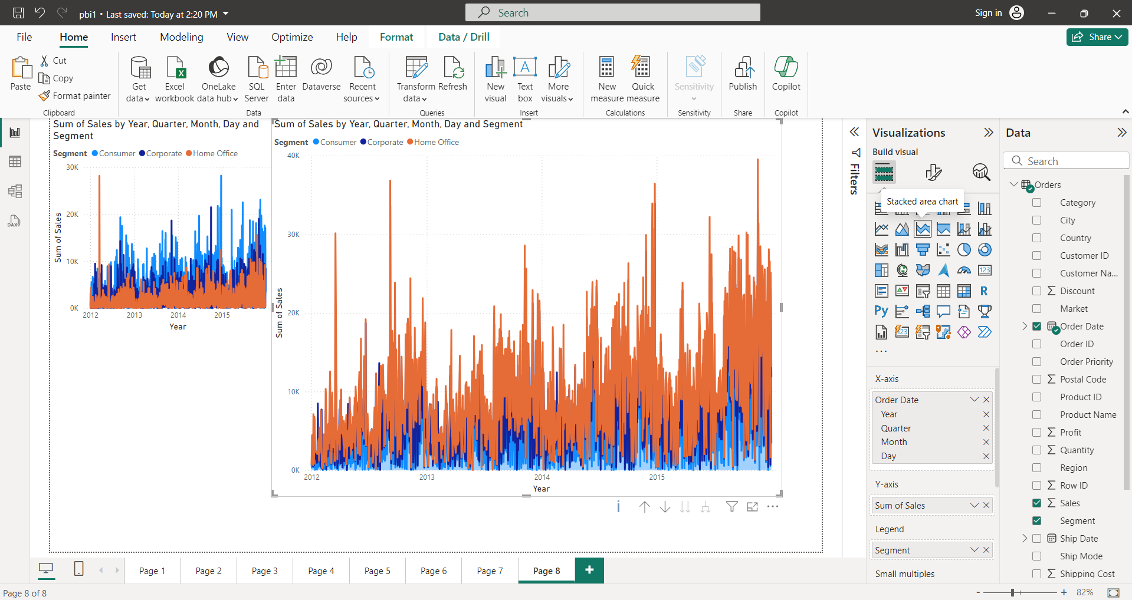

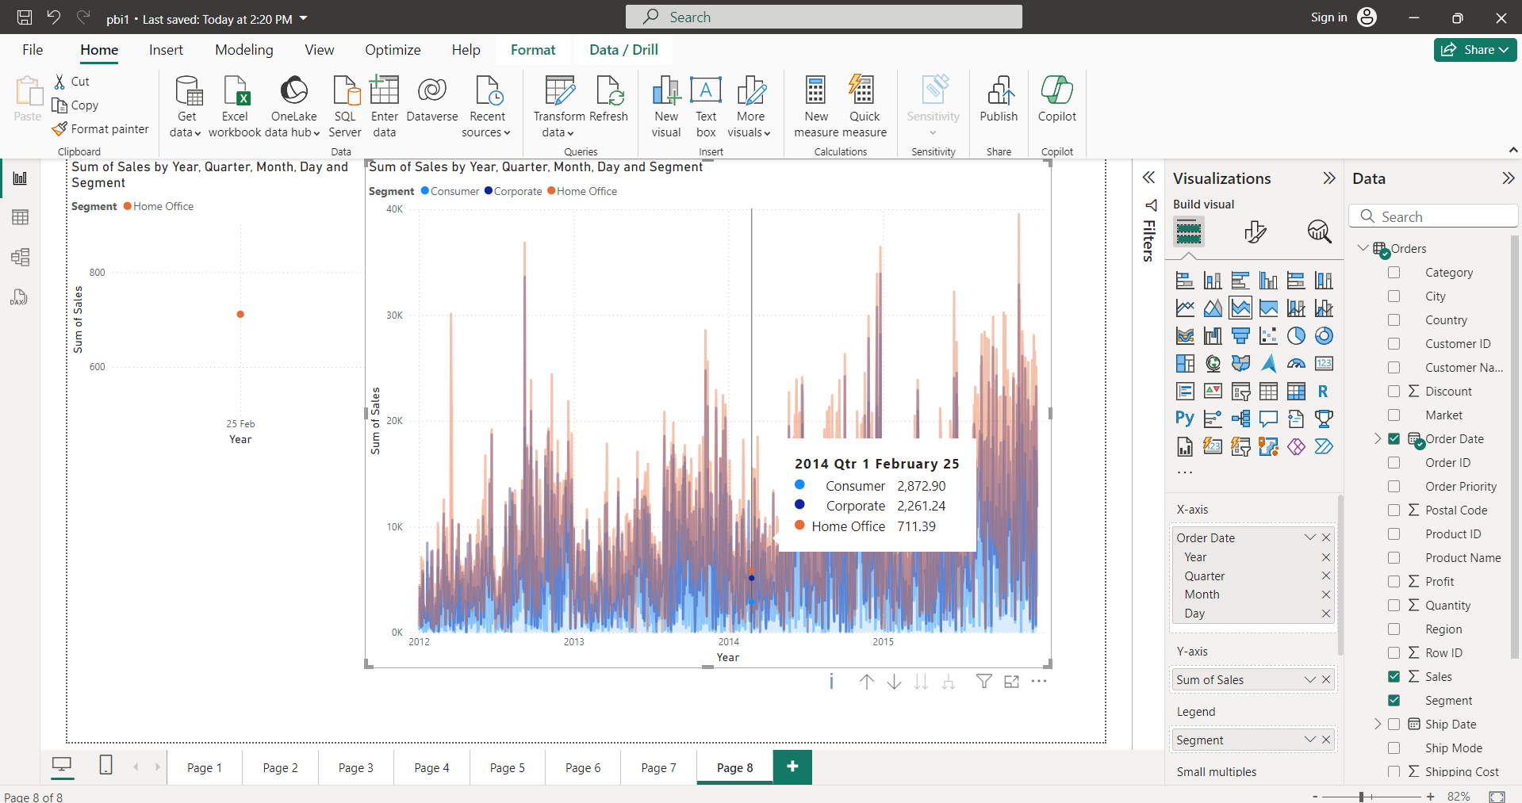

100% STACKED AREA CHART:

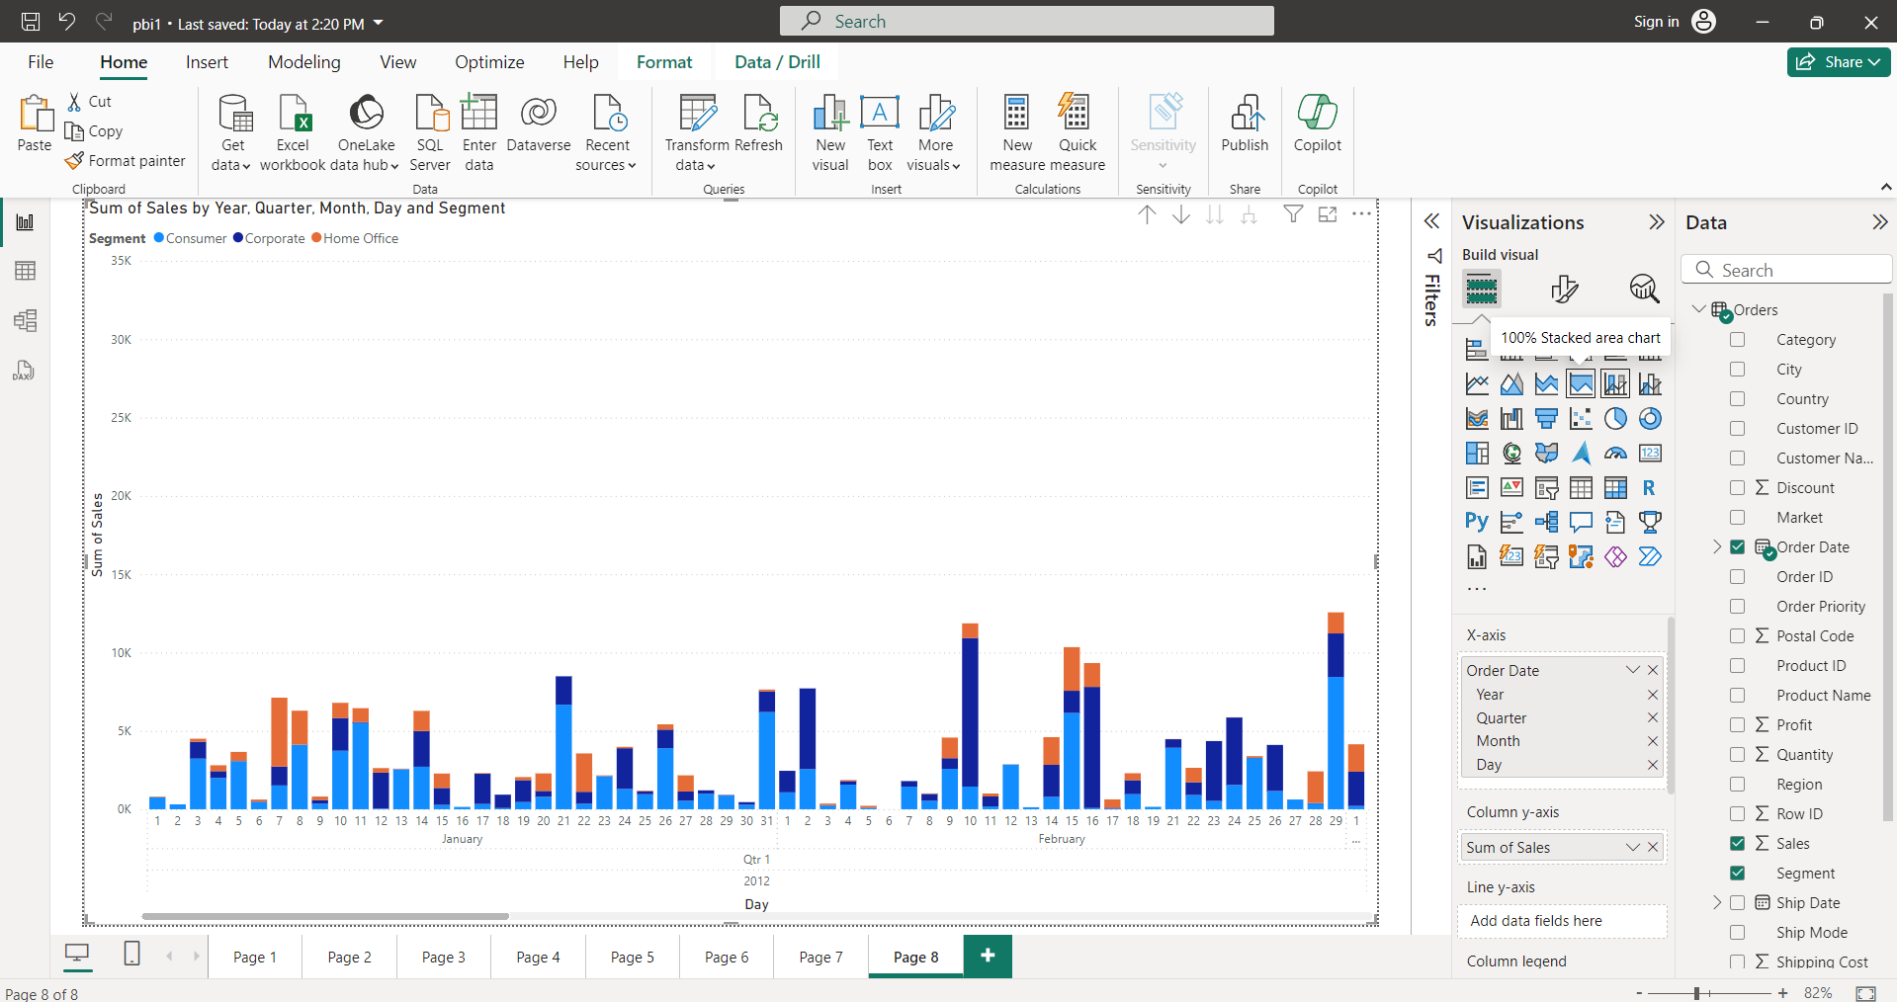

LINE AND STACKED COLUMN CHART:

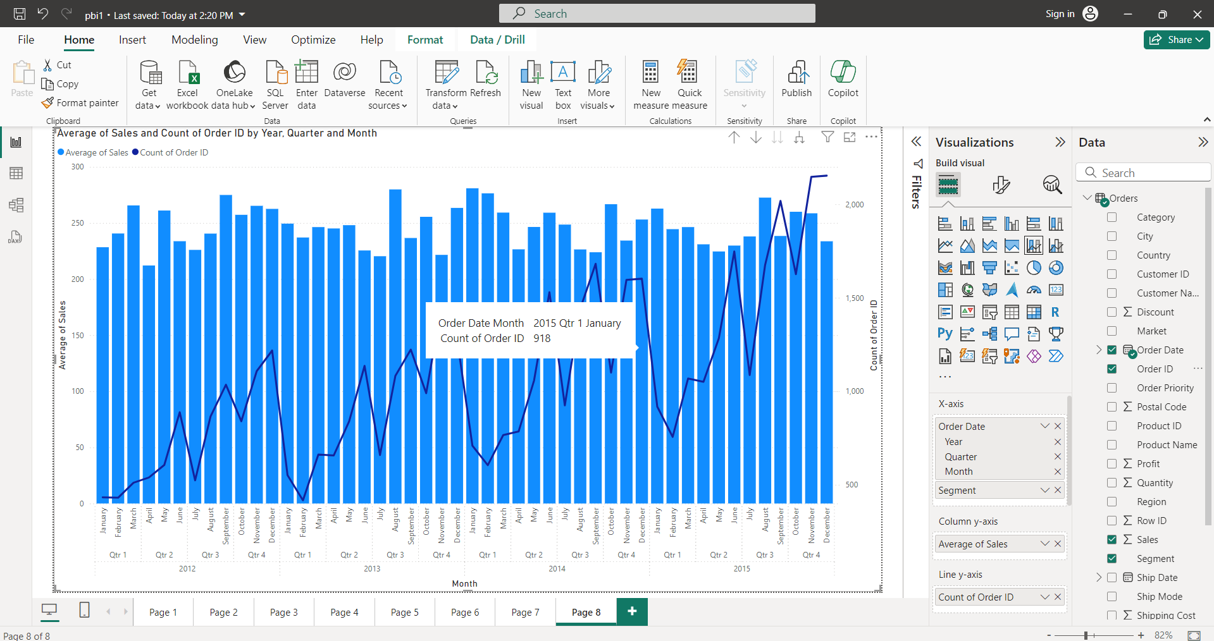

RIBBON CHART:

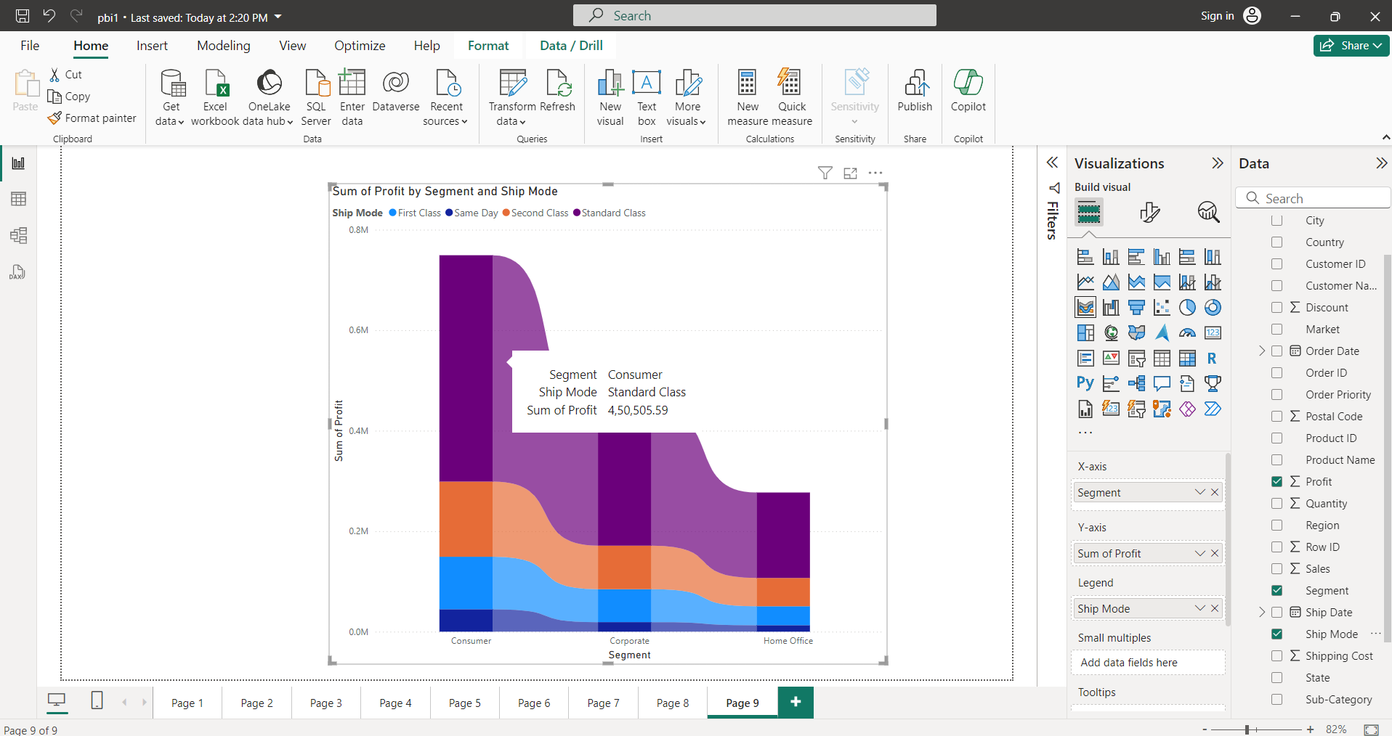

WATERFALL CHART:

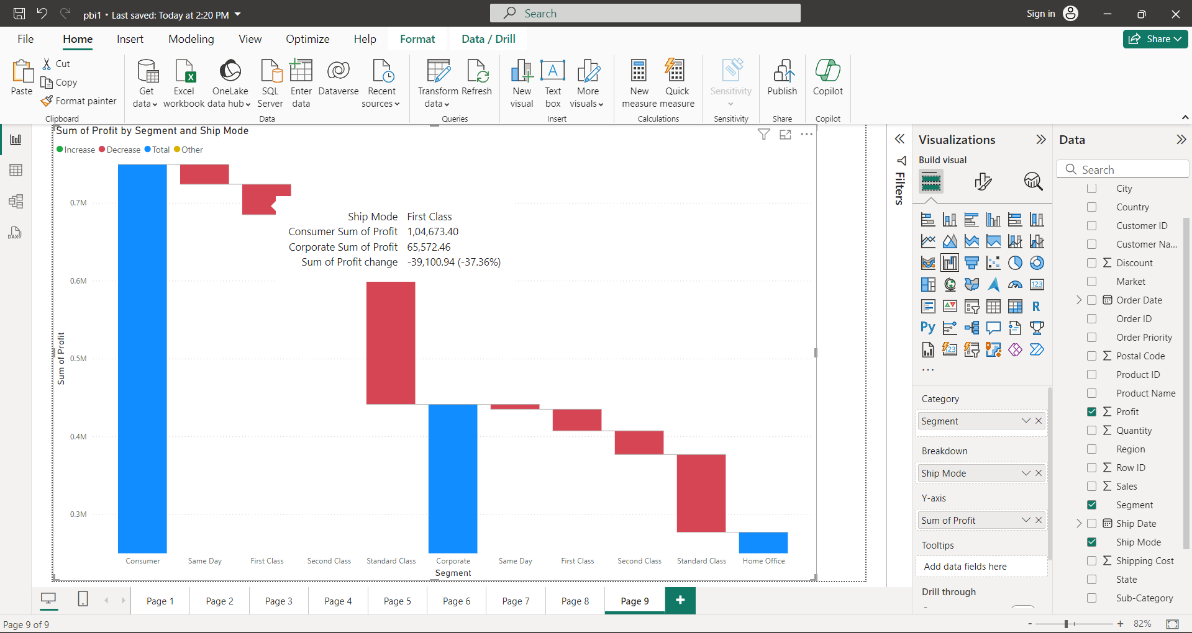

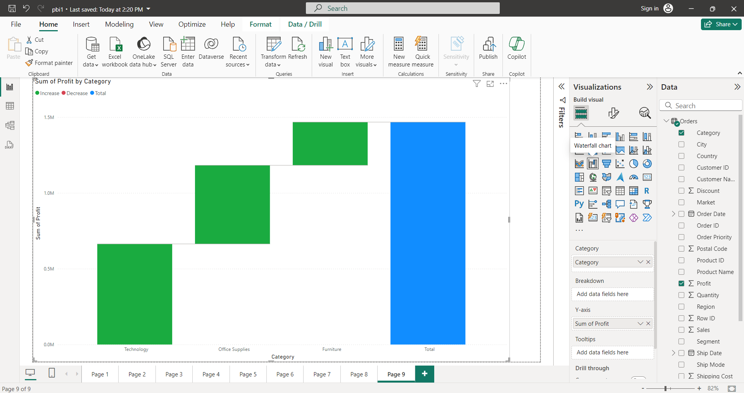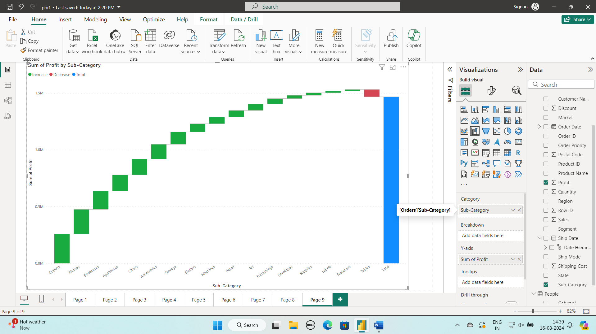

FUNNEL CHART:

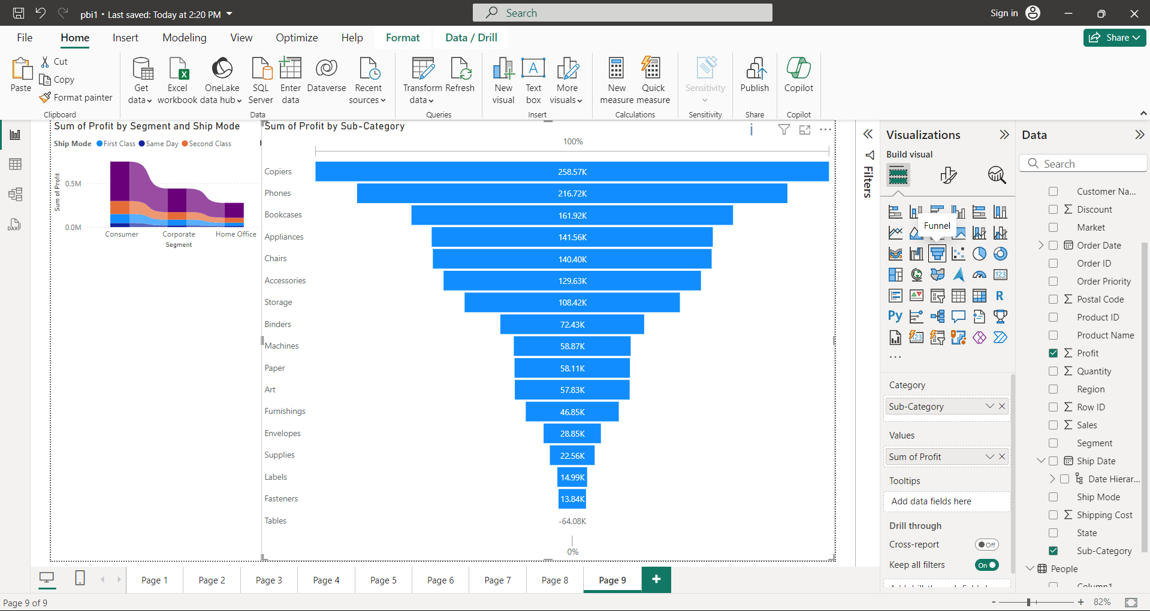

SCATTER CHART:

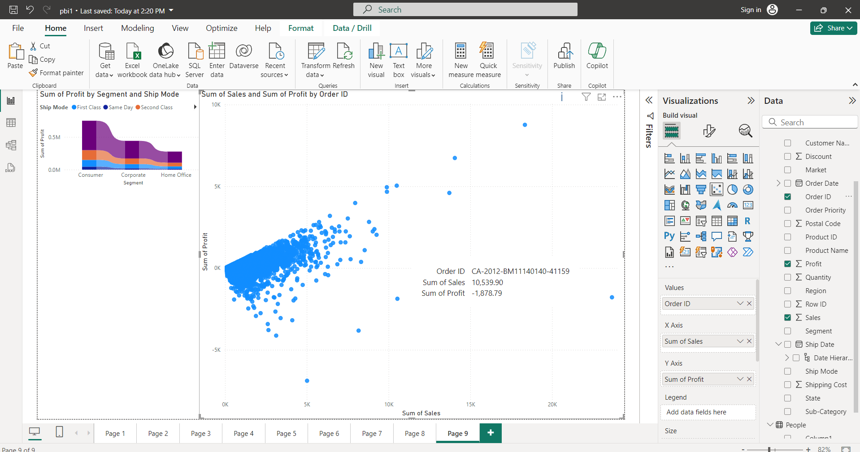

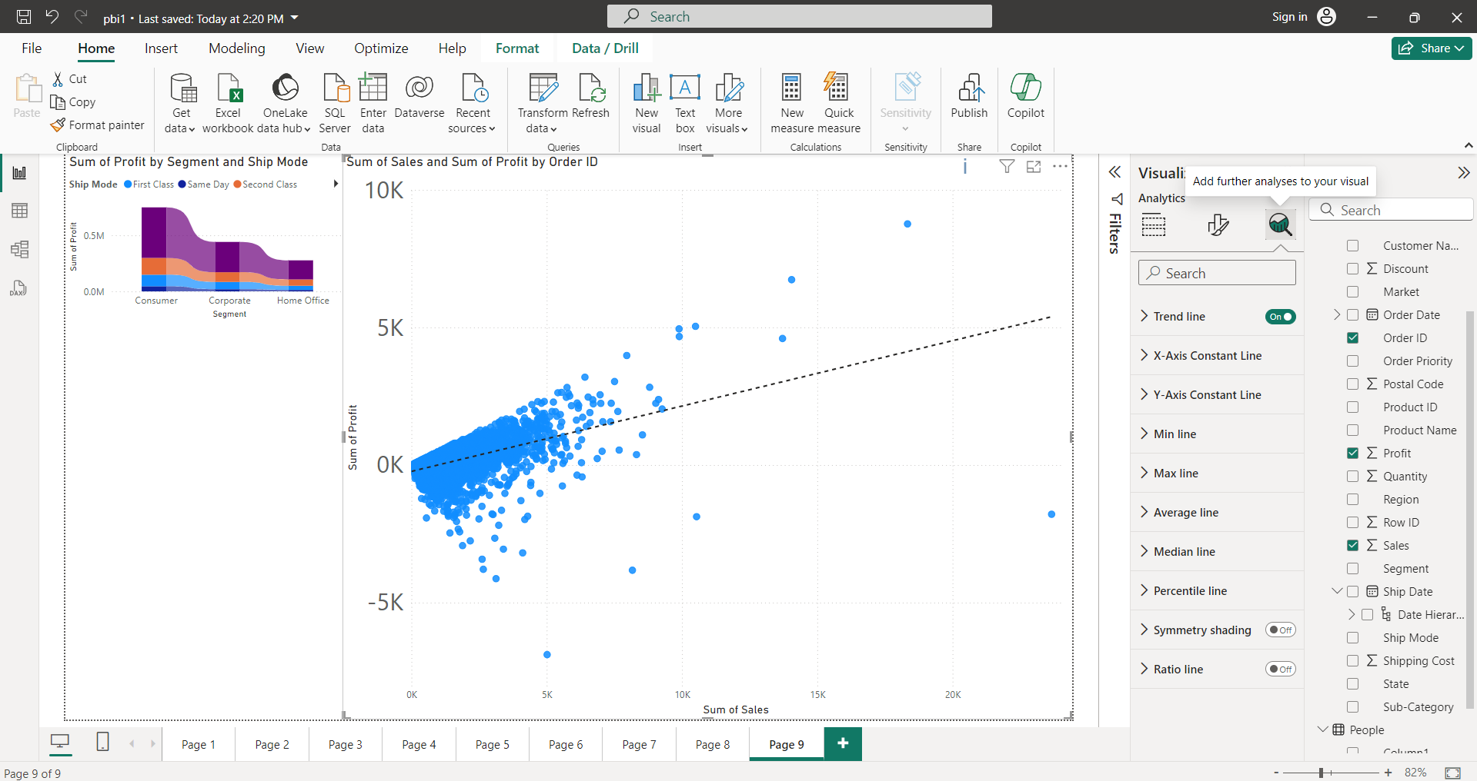

**Pie chart:**

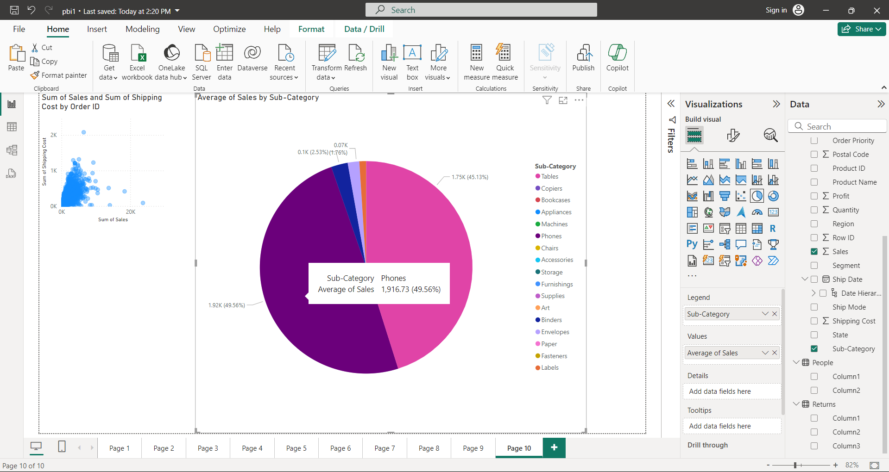

DONUT CHART:

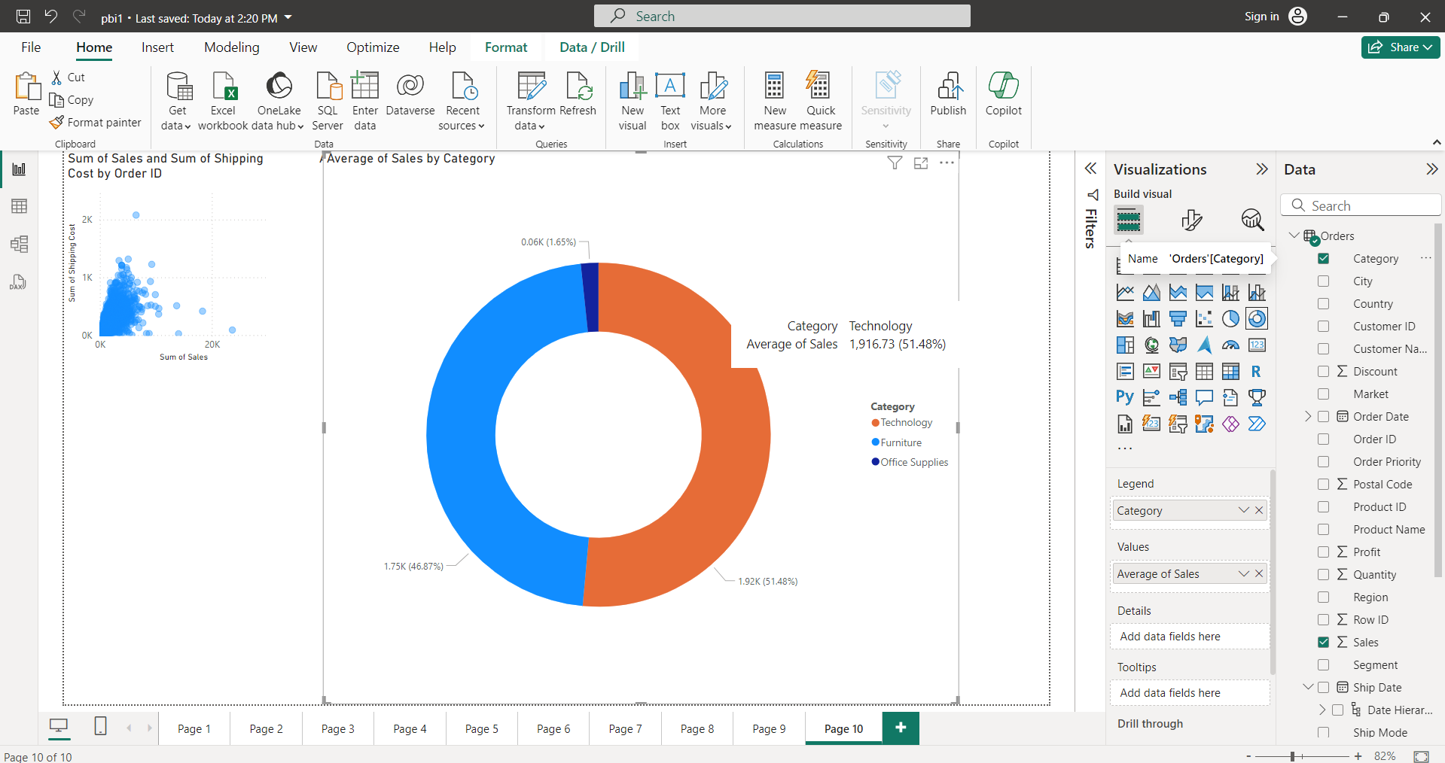

TREE MAP:

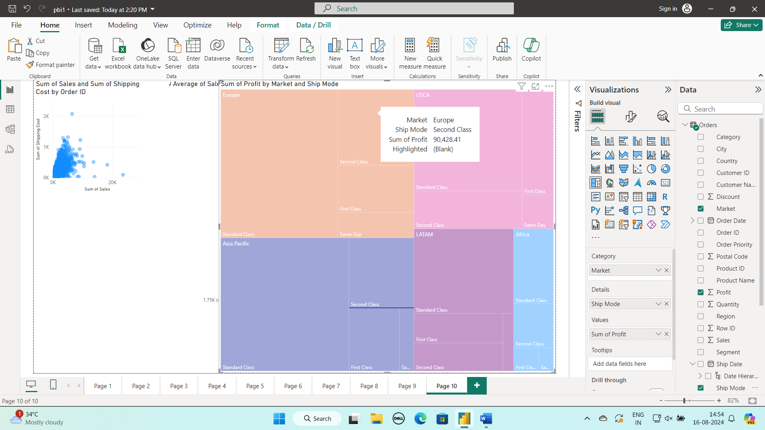

MAP:

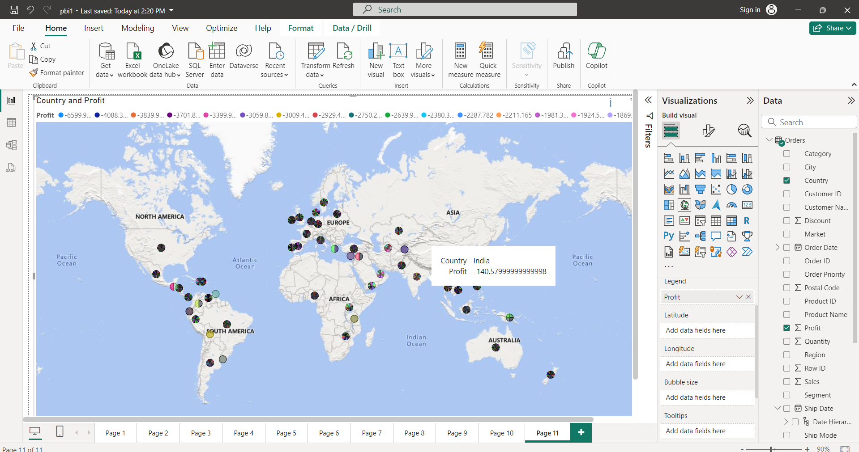slicer:

Among all countries Afganisthan is selected, so all visuals on dashboards are sliced to Afganisthan.

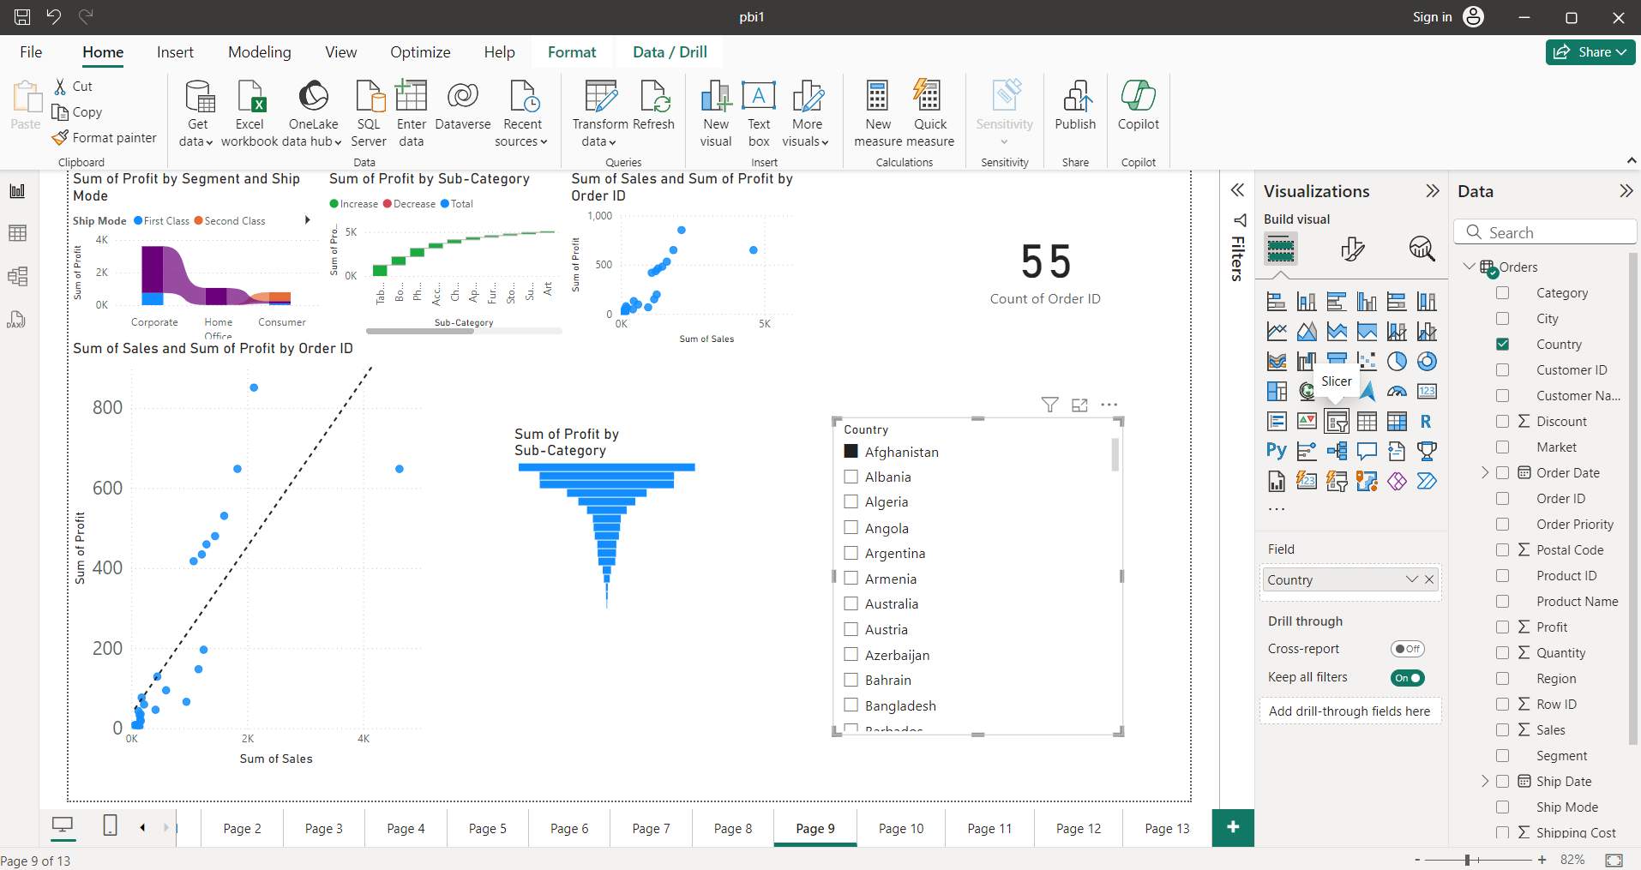

Decomposition tree:

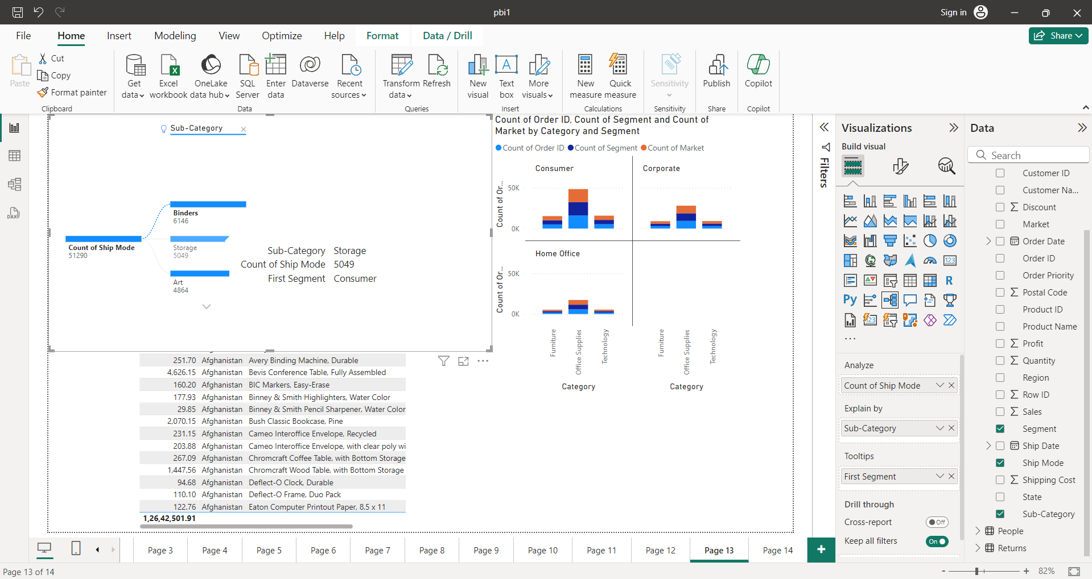

Q&A: SIMILAR TO CHATGPT

